(a). Linear Interpolation applying step size t=0.2day
Using Matlab to solve:
For January:
>> t=linspace(1,31,31);
>> Q=[278743.68, 290969.28, 298304.64, 298304.64, 322755.84, 290969.28, 286079.04, 281188.8, 276298.56, 273853.44, 276298.56, 281188.8, 281188.8, 273853.44, 266518.08, 266518.08, 271408.32, 268963.2, 266518.08, 266518.08, 266518.08, 264072.96, 264072.96, 268963.2, 266518.08, 261627.84, 261627.84, 268963.2, 408335.04, 337426.56, 315420.48];
>> tt=linspace(1,31,151);
>> vl=interp1(t,Q,tt)
vl =
1.0e+005 *
Columns 1 through 7
2.7874 2.8119 2.8363 2.8608 2.8852 2.9097 2.9244
Columns 8 through 14
2.9390 2.9537 2.9684 2.9830 2.9830 2.9830 2.9830
Columns 15 through 21
2.9830 2.9830 3.0319 3.0809 3.1298 3.1787 3.2276
Columns 22 through 28
3.1640 3.1004 3.0368 2.9733 2.9097 2.8999 2.8901
Columns 29 through 35
2.8804 2.8706 2.8608 2.8510 2.8412 2.8314 2.8217
Columns 36 through 42
2.8119 2.8021 2.7923 2.7825 2.7728 2.7630 2.7581
Columns 43 through 49
2.7532 2.7483 2.7434 2.7385 2.7434 2.7483 2.7532
Columns 50 through 56
2.7581 2.7630 2.7728 2.7825 2.7923 2.8021 2.8119
Columns 57 through 63
2.8119 2.8119 2.8119 2.8119 2.8119 2.7972 2.7825
Columns 64 through 70
2.7679 2.7532 2.7385 2.7239 2.7092 2.6945 2.6799
Columns 71 through 77
2.6652 2.6652 2.6652 2.6652 2.6652 2.6652 2.6750
Columns 78 through 84
2.6847 2.6945 2.7043 2.7141 2.7092 2.7043 2.6994
Columns 85 through 91
2.6945 2.6896 2.6847 2.6799 2.6750 2.6701 2.6652
Columns 92 through 98
2.6652 2.6652 2.6652 2.6652 2.6652 2.6652 2.6652
Columns 99 through 105
2.6652 2.6652 2.6652 2.6603 2.6554 2.6505 2.6456
Columns 106 through 112
2.6407 2.6407 2.6407 2.6407 2.6407 2.6407 2.6505
Columns 113 through 119
2.6603 2.6701 2.6799 2.6896 2.6847 2.6799 2.6750
Columns 120 through 126
2.6701 2.6652 2.6554 2.6456 2.6358 2.6261 2.6163
Columns 127 through 133
2.6163 2.6163 2.6163 2.6163 2.6163 2.6309 2.6456
Columns 134 through 140
2.6603 2.6750 2.6896 2.9684 3.2471 3.5259 3.8046
Columns 141 through 147
4.0834 3.9415 3.7997 3.6579 3.5161 3.3743 3.3303
Columns 148 through 151
3.2862 3.2422 3.1982 3.1542
>>plot(t,Q,'o',tt,vl)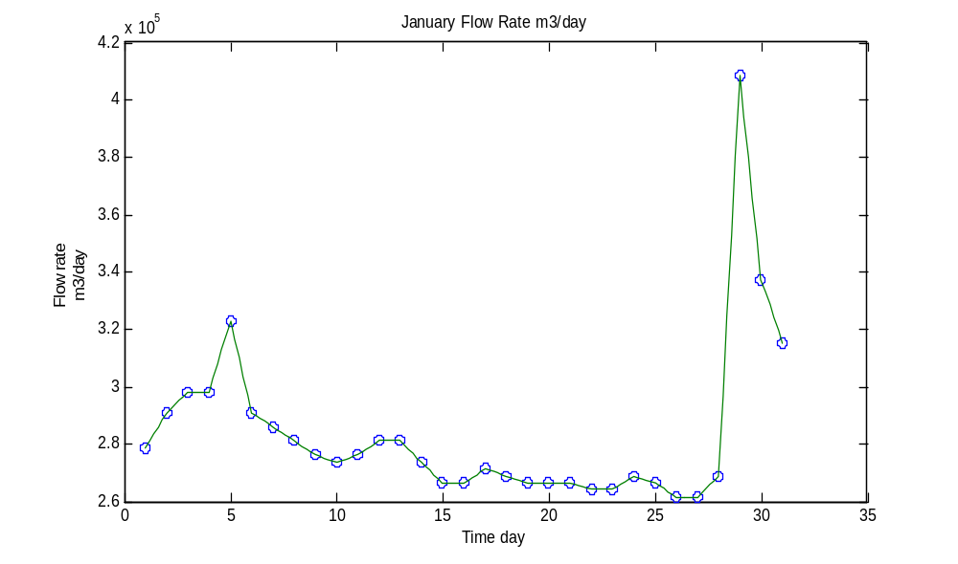
For February:
>> t2=linspace(1,28,28) ;
>> Q2=[308085.12, 305640, 300749.76, 303194.88, 308085.12, 300749.76, 295859.52, 290969.28, 286079.04, 286079.04, 283633.92, 283633.92, 283633.92, 283633.92, 288524.16, 293414.4, 298304.64, 278743.68, 283633.92, 283633.92, 286079.04, 283633.92, 283633.92, 281188.8, 281188.8, 278743.68, 278743.68, 273853.44] ;
>> tt2=linspace(1,28,136) ;
>> vl2=interp1(t2,Q2,tt2)
vl2 =
1.0e+005 *
Columns 1 through 7
3.0809 3.0760 3.0711 3.0662 3.0613 3.0564 3.0466
Columns 8 through 14
3.0368 3.0271 3.0173 3.0075 3.0124 3.0173 3.0222
Columns 15 through 21
3.0271 3.0319 3.0417 3.0515 3.0613 3.0711 3.0809
Columns 22 through 28
3.0662 3.0515 3.0368 3.0222 3.0075 2.9977 2.9879
Columns 29 through 35
2.9782 2.9684 2.9586 2.9488 2.9390 2.9293 2.9195
Columns 36 through 42
2.9097 2.8999 2.8901 2.8804 2.8706 2.8608 2.8608
Columns 43 through 49
2.8608 2.8608 2.8608 2.8608 2.8559 2.8510 2.8461
Columns 50 through 56
2.8412 2.8363 2.8363 2.8363 2.8363 2.8363 2.8363
Columns 57 through 63
2.8363 2.8363 2.8363 2.8363 2.8363 2.8363 2.8363
Columns 64 through 70
2.8363 2.8363 2.8363 2.8461 2.8559 2.8657 2.8755
Columns 71 through 77
2.8852 2.8950 2.9048 2.9146 2.9244 2.9341 2.9439
Columns 78 through 84
2.9537 2.9635 2.9733 2.9830 2.9439 2.9048 2.8657
Columns 85 through 91
2.8266 2.7874 2.7972 2.8070 2.8168 2.8266 2.8363
Columns 92 through 98
2.8363 2.8363 2.8363 2.8363 2.8363 2.8412 2.8461
Columns 99 through 105
2.8510 2.8559 2.8608 2.8559 2.8510 2.8461 2.8412
Columns 106 through 112
2.8363 2.8363 2.8363 2.8363 2.8363 2.8363 2.8314
Columns 113 through 119
2.8266 2.8217 2.8168 2.8119 2.8119 2.8119 2.8119
Columns 120 through 126
2.8119 2.8119 2.8070 2.8021 2.7972 2.7923 2.7874
Columns 127 through 133
2.7874 2.7874 2.7874 2.7874 2.7874 2.7777 2.7679
Columns 134 through 136
2.7581 2.7483 2.7385
>> plot(t2,Q2,'o',tt2,vl2)
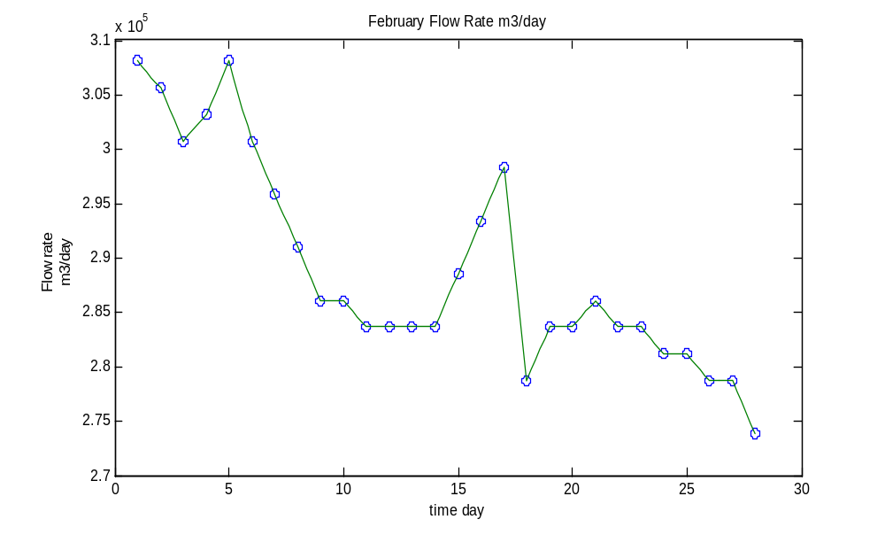
For March:
>> t3=linspace(1,31,31);
>> Q3=[273853.44, 278743.68, 276298.56, 276298.56, 276298.56, 276298.56, 273853.44, 281188.8, 300749.76, 334981.44, 327646.08, 356987.52, 398554.56, 339871.68, 312975.36, 305640, 300749.76, 295859.52, 295859.52, 293414.4, 290969.28, 293414.4, 293414.4, 293414.4, 293414.4, 293414.4, 290969.28, 290969.28, 290969.28, 293414.4, 298304.64];
>> tt3=linspace(1,31,151);
>> vl3=interp1(t3,Q3,tt3)
vl3 =
1.0e+005 *
Columns 1 through 7
2.7385 2.7483 2.7581 2.7679 2.7777 2.7874 2.7825
Columns 8 through 4
2.7777 2.7728 2.7679 2.7630 2.7630 2.7630 2.7630
Columns 15 through 21
2.7630 2.7630 2.7630 2.7630 2.7630 2.7630 2.7630
Columns 22 through 28
2.7630 2.7630 2.7630 2.7630 2.7630 2.7581 2.7532
Columns 29 through 35
2.7483 2.7434 2.7385 2.7532 2.7679 2.7825 2.7972
Columns 36 through 42
2.8119 2.8510 2.8901 2.9293 2.9684 3.0075 3.0760
Columns 43 through 49
3.1444 3.2129 3.2814 3.3498 3.3351 3.3205 3.3058
Columns 50 through 56
3.2911 3.2765 3.3351 3.3938 3.4525 3.5112 3.5699
Columns 57 through 63
3.6530 3.7361 3.8193 3.9024 3.9855 3.8682 3.7508
Columns 64 through 70
3.6334 3.5161 3.3987 3.3449 3.2911 3.2373 3.1835
Columns 71 through 77
3.1298 3.1151 3.1004 3.0857 3.0711 3.0564 3.0466
Columns 78 through 84
3.0368 3.0271 3.0173 3.0075 2.9977 2.9879 2.9782
Columns 85 through 91
2.9684 2.9586 2.9586 2.9586 2.9586 2.9586 2.9586
Columns 92 through 98
2.9537 2.9488 2.9439 2.9390 2.9341 2.9293 2.9244
Columns 99 through 105
2.9195 2.9146 2.9097 2.9146 2.9195 2.9244 2.9293
Columns 106 through 112
2.9341 2.9341 2.9341 2.9341 2.9341 2.9341 2.9341
Columns 113 through 119
2.9341 2.9341 2.9341 2.9341 2.9341 2.9341 2.9341
Columns 120 through 126
2.9341 2.9341 2.9341 2.9341 2.9341 2.9341 2.9341
Columns 127 through 133
2.9293 2.9244 2.9195 2.9146 2.9097 2.9097 2.9097
Columns 134 through 140
2.9097 2.9097 2.9097 2.9097 2.9097 2.9097 2.9097
Columns 141 through 147
2.9097 2.9146 2.9195 2.9244 2.9293 2.9341 2.9439
Columns 148 through 151
2.9537 2.9635 2.9733 2.9830
>> plot(t3,Q3,'o',tt3,vl3)
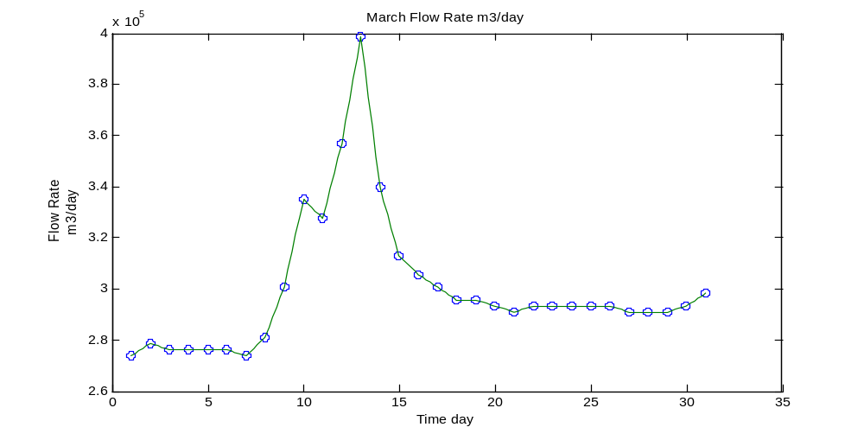
For April:
>> t4=linspace(1,30,30);
>> Q4=[298304.64, 288524.16, 398554.56, 30091.2, 305640, 298304.64, 293414.4, 288524.16, 286079.04, 286079.04, 283633.92, 293414.4, 288524.16, 286079.04, 281188.8, 278743.68, 273853.44, 273853.44, 271408.32, 271408.32, 268963.2, 271408.32, 303194.88, 288524.16, 283633.92, 278743.68, 273853.44, 268963.2, 268963.2, 266518.08];
>> tt4=linspace(1,30,146);
>> vl4=interp1(t4,Q4,tt4)
vl4 =
1.0e+005 *
Columns 1 through 7
2.9830 2.9635 2.9439 2.9244 2.9048 2.8852 3.1053
Columns 8 through 14
3.3254 3.5454 3.7655 3.9855 3.8486 3.7117 3.5748
Columns 15 through 21
3.4378 3.3009 3.2520 3.2031 3.1542 3.1053 3.0564
Columns 22 through 28
3.0417 3.0271 3.0124 2.9977 2.9830 2.9733 2.9635
Columns 29 through 35
2.9537 2.9439 2.9341 2.9244 2.9146 2.9048 2.8950
Columns 36 through 42
2.8852 2.8804 2.8755 2.8706 2.8657 2.8608 2.8608
Columns 43 through 49
2.8608 2.8608 2.8608 2.8608 2.8559 2.8510 2.8461
Columns 50 through 56
2.8412 2.8363 2.8559 2.8755 2.8950 2.9146 2.9341
Columns 57 through 63
2.9244 2.9146 2.9048 2.8950 2.8852 2.8804 2.8755
Columns 64 through 70
2.8706 2.8657 2.8608 2.8510 2.8412 2.8314 2.8217
Columns 71 through 77
2.8119 2.8070 2.8021 2.7972 2.7923 2.7874 2.7777
Columns 78 through 84
2.7679 2.7581 2.7483 2.7385 2.7385 2.7385 2.7385
Columns 85 through 91
2.7385 2.7385 2.7336 2.7288 2.7239 2.7190 2.7141
Columns 92 through 98
2.7141 2.7141 2.7141 2.7141 2.7141 2.7092 2.7043
Columns 99 through 105
2.6994 2.6945 2.6896 2.6945 2.6994 2.7043 2.7092
Columns 106 through 112
2.7141 2.7777 2.8412 2.9048 2.9684 3.0319 3.0026
Columns 113 through 119
2.9733 2.9439 2.9146 2.8852 2.8755 2.8657 2.8559
Columns 120 through 126
2.8461 2.8363 2.8266 2.8168 2.8070 2.7972 2.7874
Columns 127 through 133
2.7777 2.7679 2.7581 2.7483 2.7385 2.7288 2.7190
Columns 134 through 140
2.7092 2.6994 2.6896 2.6896 2.6896 2.6896 2.6896
Columns 141 through 146
2.6896 2.6847 2.6799 2.6750 2.6701 2.6652
>> plot(t4,Q4,'o',tt4,vl4)
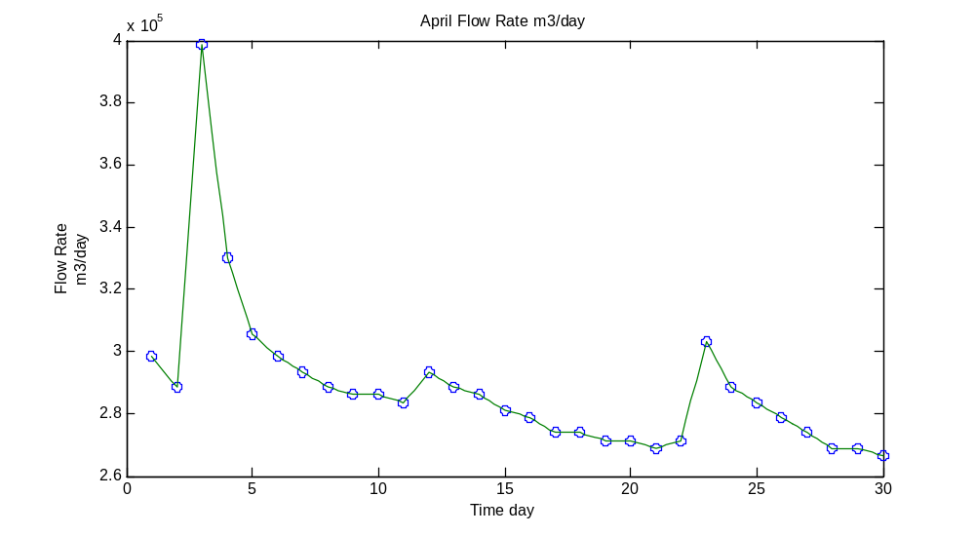
For May:
>> t5=linspace(1,31,31);
>> Q5=[266518.08, 286079.04, 286079.04, 273853.44, 271408.32, 268963.2, 268963.2, 266518.08, 261627.84, 276298.56, 442566.72, 354542.4, 315420.48, 308085.12, 303194.88, 300749.76, 298304.64, 308085.12, 303194.88, 295859.52, 295859.52, 290969.28, 288524.16, 286079.04, 286079.04, 288524.16, 286079.04, 315420.48, 300749.76, 293414.4, 300749.76] ;
>> tt5=linspace(1,31,151)
>> vl5=interp1(t5,Q5,tt5)
vl5 =
1.0e+005 *
Columns 1 through 7
2.6652 2.7043 2.7434 2.7825 2.8217 2.8608 2.8608
Columns 8 through 14
2.8608 2.8608 2.8608 2.8608 2.8363 2.8119 2.7874
Columns 15 through 21
2.7630 2.7385 2.7336 2.7288 2.7239 2.7190 2.7141
Columns 22 through 28
2.7092 2.7043 2.6994 2.6945 2.6896 2.6896 2.6896
Columns 29 through 35
2.6896 2.6896 2.6896 2.6847 2.6799 2.6750 2.6701
Columns 36 through 42
2.6652 2.6554 2.6456 2.6358 2.6261 2.6163 2.6456
Columns 43 through 49
2.6750 2.7043 2.7336 2.7630 3.0955 3.4281 3.7606
Columns 50 through 56
4.0931 4.4257 4.2496 4.0736 3.8975 3.7215 3.5454
Columns 57 through 63
3.4672 3.3889 3.3107 3.2324 3.1542 3.1395 3.1249
Columns 64 through 70
3.1102 3.0955 3.0809 3.0711 3.0613 3.0515 3.0417
Columns 71 through 77
3.0319 3.0271 3.0222 3.0173 3.0124 3.0075 3.0026
Columns 78 through 84
2.9977 2.9928 2.9879 2.9830 3.0026 3.0222 3.0417
Columns 85 through 91
3.0613 3.0809 3.0711 3.0613 3.0515 3.0417 3.0319
Columns 92 through 98
3.0173 3.0026 2.9879 2.9733 2.9586 2.9586 2.9586
Columns 99 through 105
2.9586 2.9586 2.9586 2.9488 2.9390 2.9293 2.9195
Columns 106 through 112
2.9097 2.9048 2.8999 2.8950 2.8901 2.8852 2.8804
Columns 113 through 119
2.8755 2.8706 2.8657 2.8608 2.8608 2.8608 2.8608
Columns 120 through 126
2.8608 2.8608 2.8657 2.8706 2.8755 2.8804 2.8852
Columns 127 through 133
2.8804 2.8755 2.8706 2.8657 2.8608 2.9195 2.9782
Columns 134 through 140
3.0368 3.0955 3.1542 3.1249 3.0955 3.0662 3.0368
Columns 141 through 147
3.0075 2.9928 2.9782 2.9635 2.9488 2.9341 2.9488
Columns 148 through 151
2.9635 2.9782 2.9928 3.0075
>> plot(t5,Q5,'o',tt5,vl5)
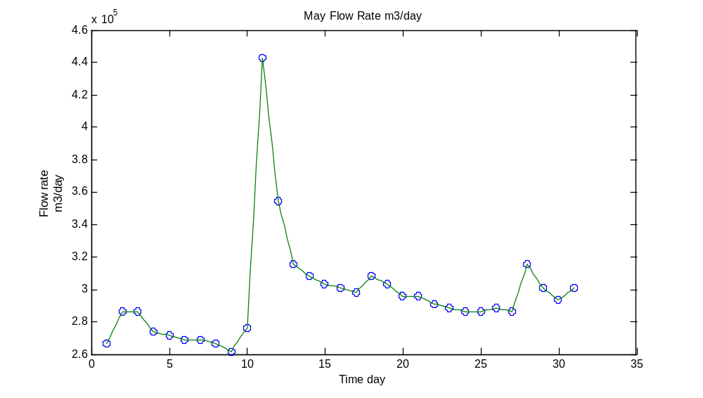
For June:
>> t6=linspace(1,30,30);
>>Q6=[293414.4, 288524.16, 286079.04, 283633.92, 281188.8, 283633.92, 327646.08, 298304.64, 288524.16, 283633.92, 281188.8, 278743.68, 276298.56, 276298.56, 271408.32, 271408.32, 266518.08, 281188.8, 276298.56, 271408.32, 283633.92, 276298.56, 268963.2, 266518.08, 271408.32, 271408.32, 271408.32, 266518.08, 266518.08, 271408.32];
>> tt6=linspace(1,30,146);
>> vl6=interp1(t6,Q6,tt6)
vl6 =
1.0e+005 *
Columns 1 through 7
2.9341 2.9244 2.9146 2.9048 2.8950 2.8852 2.8804
Columns 8 through 14
2.8755 2.8706 2.8657 2.8608 2.8559 2.8510 2.8461
Columns 15 through 21
2.8412 2.8363 2.8314 2.8266 2.8217 2.8168 2.8119
Columns 22 through 28
2.8168 2.8217 2.8266 2.8314 2.8363 2.9244 3.0124
Columns 29 through 35
3.1004 3.1884 3.2765 3.2178 3.1591 3.1004 3.0417
Columns 36 through 42
2.9830 2.9635 2.9439 2.9244 2.9048 2.8852 2.8755
Columns 43 through 49
2.8657 2.8559 2.8461 2.8363 2.8314 2.8266 2.8217
Columns 50 through 56
2.8168 2.8119 2.8070 2.8021 2.7972 2.7923 2.7874
Columns 57 through 63
2.7825 2.7777 2.7728 2.7679 2.7630 2.7630 2.7630
Columns 64 through 70
2.7630 2.7630 2.7630 2.7532 2.7434 2.7336 2.7239
Columns 71 through 77
2.7141 2.7141 2.7141 2.7141 2.7141 2.7141 2.7043
Columns 78 through 84
2.6945 2.6847 2.6750 2.6652 2.6945 2.7239 2.7532
Columns 85 through 91
2.7825 2.8119 2.8021 2.7923 2.7825 2.7728 2.7630
Columns 92 through 98
2.7532 2.7434 2.7336 2.7239 2.7141 2.7385 2.7630
Columns 99 through 105
2.7874 2.8119 2.8363 2.8217 2.8070 2.7923 2.7777
Columns 106 through 112
2.7630 2.7483 2.7336 2.7190 2.7043 2.6896 2.6847
Columns 113 through 119
2.6799 2.6750 2.6701 2.6652 2.6750 2.6847 2.6945
Columns 120 through 126
2.7043 2.7141 2.7141 2.7141 2.7141 2.7141 2.7141
Columns 127 through 133
2.7141 2.7141 2.7141 2.7141 2.7141 2.7043 2.6945
Columns 134 through 140
2.6847 2.6750 2.6652 2.6652 2.6652 2.6652 2.6652
Columns 141 through 146
2.6652 2.6750 2.6847 2.6945 2.7043 2.7141
>> plot(t6,Q6,'o',tt6,vl6)
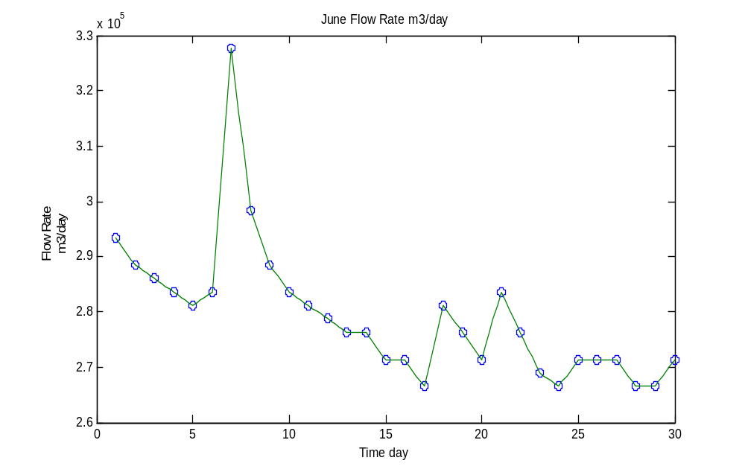
For July:
>> t7=linspace(1,31,31);
>> Q7=[268963.2, 268963.2, 266518.08, 268963.2, 264072.96, 264072.96, 266518.08, 261627.84, 273853.44, 281188.8, 271408.32, 268963.2, 264072.96, 264072.96, 264072.96, 261627.84, 276298.56, 283633.92, 271408.32, 276298.56, 271408.32, 268963.2, 266518.08, 298304.64, 276298.56, 330091.2, 293414.4, 283633.92, 278743.68, 278743.68, 276298.56];
>> tt7=linspace(1,31,151);
>> vl7=interp1(t7,Q7,tt7)
vl7 =
1.0e+005 *
Columns 1 through 7
2.6896 2.6896 2.6896 2.6896 2.6896 2.6896 2.6847
Columns 8 through 14
2.6799 2.6750 2.6701 2.6652 2.6701 2.6750 2.6799
Columns 15 through 21
2.6847 2.6896 2.6799 2.6701 2.6603 2.6505 2.6407
Columns 22 through 28
2.6407 2.6407 2.6407 2.6407 2.6407 2.6456 2.6505
Columns 29 through 35
2.6554 2.6603 2.6652 2.6554 2.6456 2.6358 2.6261
Columns 36 through 42
2.6163 2.6407 2.6652 2.6896 2.7141 2.7385 2.7532
Columns 43 through 49
2.7679 2.7825 2.7972 2.8119 2.7923 2.7728 2.7532
Columns 50 through 56
2.7336 2.7141 2.7092 2.7043 2.6994 2.6945 2.6896
Columns 57 through 63
2.6799 2.6701 2.6603 2.6505 2.6407 2.6407 2.6407
Columns 64 through 70
2.6407 2.6407 2.6407 2.6407 2.6407 2.6407 2.6407
Columns 71 through 77
2.6407 2.6358 2.6309 2.6261 2.6212 2.6163 2.6456
Columns 78 through 84
2.6750 2.7043 2.7336 2.7630 2.7777 2.7923 2.8070
Columns 85 through 91
2.8217 2.8363 2.8119 2.7874 2.7630 2.7385 2.7141
Columns 92 through 98
2.7239 2.7336 2.7434 2.7532 2.7630 2.7532 2.7434
Columns 99 through 105
2.7336 2.7239 2.7141 2.7092 2.7043 2.6994 2.6945
Columns 106 through 112
2.6896 2.6847 2.6799 2.6750 2.6701 2.6652 2.7288
Columns 113 through 119
2.7923 2.8559 2.9195 2.9830 2.9390 2.8950 2.8510
Columns 120 through 126
2.8070 2.7630 2.8706 2.9782 3.0857 3.1933 3.3009
Columns 127 through 133
3.2276 3.1542 3.0809 3.0075 2.9341 2.9146 2.8950
Columns 134 through 140
2.8755 2.8559 2.8363 2.8266 2.8168 2.8070 2.7972
Columns 141 through 147
2.7874 2.7874 2.7874 2.7874 2.7874 2.7874 2.7825
Columns 148 through 151
2.7777 2.7728 2.7679 2.7630
>> plot(t7,Q7,'o',tt7,vl7)
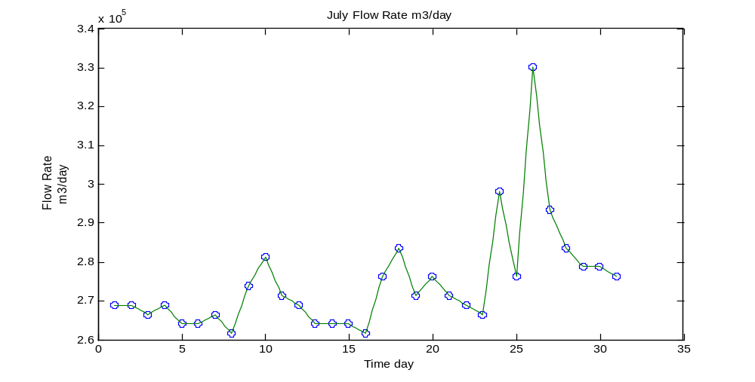
For August:
>> t8=linspace(1,31,31);
>> Q8=[276298.56, 364322.88, 305640, 293414.4, 286079.04, 286079.04, 283633.92, 281188.8, 278743.68, 281188.8, 278743.68, 273853.44, 273853.44, 276298.56, 273853.44, 271408.32, 273853.44, 273853.44, 276298.56, 276298.56, 271408.32, 271408.32, 276298.56, 281188.8, 359432.64, 315420.48, 308085.12, 300749.76, 298304.64, 293414.4, 288524.16];
>> tt8=linspace(1,31,151);
>> vl8=interp1(t8,Q8,tt8)
vl8 =
1.0e+005 *
Columns 1 through 7
2.7630 2.9390 3.1151 3.2911 3.4672 3.6432 3.5259
Columns 8 through 14
3.4085 3.2911 3.1738 3.0564 3.0319 3.0075 2.9830
Columns 15 through 21
2.9586 2.9341 2.9195 2.9048 2.8901 2.8755 2.8608
Columns 22 through 28
2.8608 2.8608 2.8608 2.8608 2.8608 2.8559 2.8510
Columns 29 through 35
2.8461 2.8412 2.8363 2.8314 2.8266 2.8217 2.8168
Columns 36 through 42
2.8119 2.8070 2.8021 2.7972 2.7923 2.7874 2.7923
Columns 43 through 49
2.7972 2.8021 2.8070 2.8119 2.8070 2.8021 2.7972
Columns 50 through 56
2.7923 2.7874 2.7777 2.7679 2.7581 2.7483 2.7385
Columns 57 through 63
2.7385 2.7385 2.7385 2.7385 2.7385 2.7434 2.7483
Columns 64 through 70
2.7532 2.7581 2.7630 2.7581 2.7532 2.7483 2.7434
Columns 71 through 77
2.7385 2.7336 2.7288 2.7239 2.7190 2.7141 2.7190
Columns 78 through 84
2.7239 2.7288 2.7336 2.7385 2.7385 2.7385 2.7385
Columns 85 through 91
2.7385 2.7385 2.7434 2.7483 2.7532 2.7581 2.7630
Columns 92 through 98
2.7630 2.7630 2.7630 2.7630 2.7630 2.7532 2.7434
Columns 99 through 105
2.7336 2.7239 2.7141 2.7141 2.7141 2.7141 2.7141
Columns 106 through 112
2.7141 2.7239 2.7336 2.7434 2.7532 2.7630 2.7728
Columns 113 through 119
2.7825 2.7923 2.8021 2.8119 2.9684 3.1249 3.2814
Columns 120 through 126
3.4378 3.5943 3.5063 3.4183 3.3303 3.2422 3.1542
Columns 127 through 133
3.1395 3.1249 3.1102 3.0955 3.0809 3.0662 3.0515
Columns 134 through 140
3.0368 3.0222 3.0075 3.0026 2.9977 2.9928 2.9879
Columns 141 through 147
2.9830 2.9733 2.9635 2.9537 2.9439 2.9341 2.9244
Columns 148 through 151
2.9146 2.9048 2.8950 2.8852
>> plot(t8,Q8,'o',tt8,vl8)
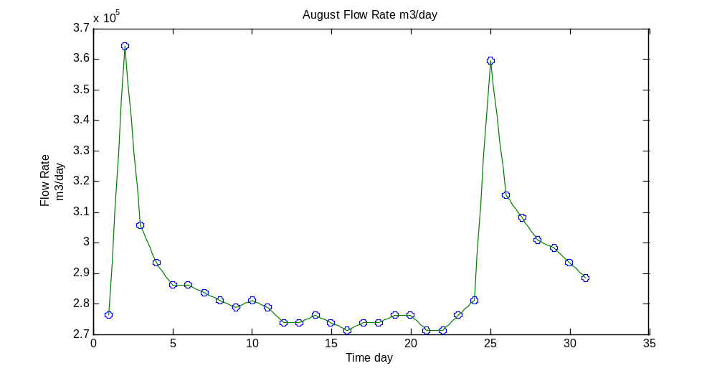
For September:
>> t9=linspace(1,30,30);
>> Q9=[286079.04, 286079.04, 286079.04, 286079.04, 283633.92, 278743.68, 276298.56, 276298.56, 290969.28, 281188.8, 281188.8, 339871.68, 308085.12, 300749.76, 293414.4, 290969.28, 290969.28, 308085.12, 298304.64, 293414.4, 288524.16, 286079.04, 290969.28, 312975.36, 293414.4, 288524.16, 315420.48, 308085.12, 305640, 310530.24];
>> tt9=linspace(1,30,146);
>> vl9=interp1(t9,Q9,tt9)
vl9 =
1.0e+005 *
Columns 1 through 7
2.8608 2.8608 2.8608 2.8608 2.8608 2.8608 2.8608
Columns 8 through 14
2.8608 2.8608 2.8608 2.8608 2.8608 2.8608 2.8608
Columns 15 through 21
2.8608 2.8608 2.8559 2.8510 2.8461 2.8412 2.8363
Columns 22 through 28
2.8266 2.8168 2.8070 2.7972 2.7874 2.7825 2.7777
Columns 29 through 35
2.7728 2.7679 2.7630 2.7630 2.7630 2.7630 2.7630
Columns 36 through 42
2.7630 2.7923 2.8217 2.8510 2.8804 2.9097 2.8901
Columns 43 through 49
2.8706 2.8510 2.8314 2.8119 2.8119 2.8119 2.8119
Columns 50 through 56
2.8119 2.8119 2.9293 3.0466 3.1640 3.2814 3.3987
Columns 57 through 63
3.3351 3.2716 3.2080 3.1444 3.0809 3.0662 3.0515
Columns 64 through 70
3.0368 3.0222 3.0075 2.9928 2.9782 2.9635 2.9488
Columns 71 through 77
2.9341 2.9293 2.9244 2.9195 2.9146 2.9097 2.9097
Columns 78 through 84
2.9097 2.9097 2.9097 2.9097 2.9439 2.9782 3.0124
Columns 85 through 91
3.0466 3.0809 3.0613 3.0417 3.0222 3.0026 2.9830
Columns 92 through 98
2.9733 2.9635 2.9537 2.9439 2.9341 2.9244 2.9146
Columns 99 through 105
2.9048 2.8950 2.8852 2.8804 2.8755 2.8706 2.8657
Columns 106 through 112
2.8608 2.8706 2.8804 2.8901 2.8999 2.9097 2.9537
Columns 113 through 119
2.9977 3.0417 3.0857 3.1298 3.0906 3.0515 3.0124
Columns 120 through 126
2.9733 2.9341 2.9244 2.9146 2.9048 2.8950 2.8852
Columns 127 through 133
2.9390 2.9928 3.0466 3.1004 3.1542 3.1395 3.1249
Columns 134 through 140
3.1102 3.0955 3.0809 3.0760 3.0711 3.0662 3.0613
Columns 141 through 146
3.0564 3.0662 3.0760 3.0857 3.0955 3.1053
>> plot(t9,Q9,'o',tt9,vl9)
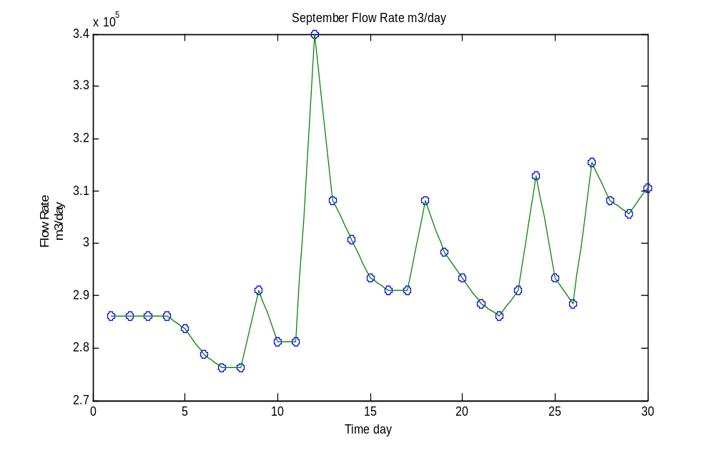
For October:
>> t10=linspace(1,31,31);
>> Q10=[295859.52, 288524.16, 283633.92, 484133.76, 322755.84, 305640, 298304.64, 290969.28, 286079.04, 286079.04, 342316.8, 359432.64, 347207.04, 342316.8, 315420.48, 305640, 347207.04, 325200.96, 322755.84, 310530.24, 303194.88, 366768, 330091.2, 317865.6, 308085.12, 298304.64, 293414.4, 317865.6, 295859.52, 288524.16, 283633.92];
>> tt10=linspace(1,31,151);
>> vl10=interp1(t10,Q10,tt10)
vl10 =
1.0e+005 *
Columns 1 through 7
2.9586 2.9439 2.9293 2.9146 2.8999 2.8852 2.8755
Columns 8 through 14
2.8657 2.8559 2.8461 2.8363 3.2373 3.6383 4.0393
Columns 15 through 21
4.4403 4.8413 4.5186 4.1958 3.8731 3.5503 3.2276
Columns 22 through 28
3.1933 3.1591 3.1249 3.0906 3.0564 3.0417 3.0271
Columns 29 through 35
3.0124 2.9977 2.9830 2.9684 2.9537 2.9390 2.9244
Columns 36 through 42
2.9097 2.8999 2.8901 2.8804 2.8706 2.8608 2.8608
Columns 43 through 49
2.8608 2.8608 2.8608 2.8608 2.9733 3.0857 3.1982
Columns 50 through 56
3.3107 3.4232 3.4574 3.4916 3.5259 3.5601 3.5943
Columns 57 through 63
3.5699 3.5454 3.5210 3.4965 3.4721 3.4623 3.4525
Columns 64 through 70
3.4427 3.4329 3.4232 3.3694 3.3156 3.2618 3.2080
Columns 71 through 77
3.1542 3.1346 3.1151 3.0955 3.0760 3.0564 3.1395
Columns 78 through 84
3.2227 3.3058 3.3889 3.4721 3.4281 3.3840 3.3400
Columns 85 through 91
3.2960 3.2520 3.2471 3.2422 3.2373 3.2324 3.2276
Columns 92 through 98
3.2031 3.1787 3.1542 3.1298 3.1053 3.0906 3.0760
Columns 99 through 105
3.0613 3.0466 3.0319 3.1591 3.2862 3.4134 3.5405
Columns 106 through 112
3.6677 3.5943 3.5210 3.4476 3.3743 3.3009 3.2765
Columns 113 through 119
3.2520 3.2276 3.2031 3.1787 3.1591 3.1395 3.1200
Columns 120 through 126
3.1004 3.0809 3.0613 3.0417 3.0222 3.0026 2.9830
Columns 127 through 133
2.9733 2.9635 2.9537 2.9439 2.9341 2.9830 3.0319
Columns 134 through 140
3.0809 3.1298 3.1787 3.1346 3.0906 3.0466 3.0026
Columns 141 through 147
2.9586 2.9439 2.9293 2.9146 2.8999 2.8852 2.8755
Columns 148 through 151
2.8657 2.8559 2.8461 2.8363
>> plot(t10,Q10,'o',tt10,vl10)
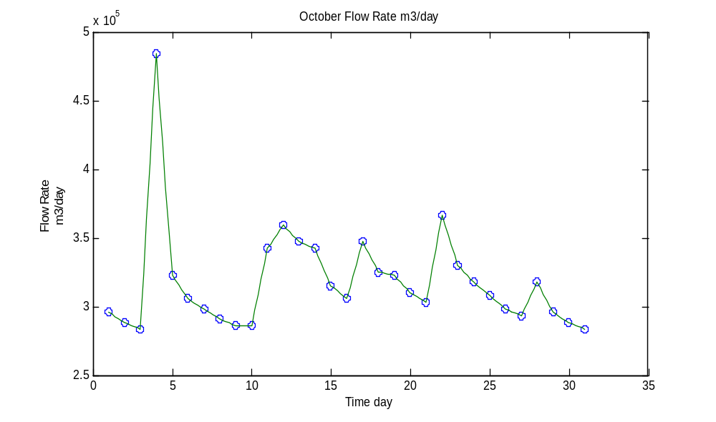
For November:
>> t11=linspace(1,30,30);
>> Q11=[281188.8, 276298.56, 276298.56, 273853.44, 273853.44, 273853.44, 271408.32, 271408.32, 268963.2, 273853.44, 312975.36, 295859.52, 286079.04, 286079.04, 283633.92, 281188.8, 276298.56, 271408.32, 276298.56, 273853.44, 271408.32, 271408.32, 268963.2, 266518.08, 266518.08, 266518.08, 276298.56, 298304.64, 290969.28, 288524.16];
>> tt11=linspace(1,30,146);
>> vl11=interp1(t11,Q11,tt11)
vl11 =
1.0e+005 *
Columns 1 through 7
2.8119 2.8021 2.7923 2.7825 2.7728 2.7630 2.7630
Columns 8 through 14
2.7630 2.7630 2.7630 2.7630 2.7581 2.7532 2.7483
Columns 15 through 21
2.7434 2.7385 2.7385 2.7385 2.7385 2.7385 2.7385
Columns 22 through 28
2.7385 2.7385 2.7385 2.7385 2.7385 2.7336 2.7288
Columns 29 through 35
2.7239 2.7190 2.7141 2.7141 2.7141 2.7141 2.7141
Columns 36 through 42
2.7141 2.7092 2.7043 2.6994 2.6945 2.6896 2.6994
Columns 43 through 49
2.7092 2.7190 2.7288 2.7385 2.8168 2.8950 2.9733
Columns 50 through 56
3.0515 3.1298 3.0955 3.0613 3.0271 2.9928 2.9586
Columns 57 through 63
2.9390 2.9195 2.8999 2.8804 2.8608 2.8608 2.8608
Columns 64 through 70
2.8608 2.8608 2.8608 2.8559 2.8510 2.8461 2.8412
Columns 71 through 77
2.8363 2.8314 2.8266 2.8217 2.8168 2.8119 2.8021
Columns 78 through 84
2.7923 2.7825 2.7728 2.7630 2.7532 2.7434 2.7336
Columns 85 through 91
2.7239 2.7141 2.7239 2.7336 2.7434 2.7532 2.7630
Columns 92 through 98
2.7581 2.7532 2.7483 2.7434 2.7385 2.7336 2.7288
Columns 99 through 105
2.7239 2.7190 2.7141 2.7141 2.7141 2.7141 2.7141
Columns 106 through 112
2.7141 2.7092 2.7043 2.6994 2.6945 2.6896 2.6847
Columns 113 through 119
2.6799 2.6750 2.6701 2.6652 2.6652 2.6652 2.6652
Columns 120 through 126
2.6652 2.6652 2.6652 2.6652 2.6652 2.6652 2.6652
Columns 127 through 133
2.6847 2.7043 2.7239 2.7434 2.7630 2.8070 2.8510
Columns 134 through 140
2.8950 2.9390 2.9830 2.9684 2.9537 2.9390 2.9244
Columns 141 through 146
2.9097 2.9048 2.8999 2.8950 2.8901 2.8852
>> plot(t11,Q11,'o',tt11,vl11)
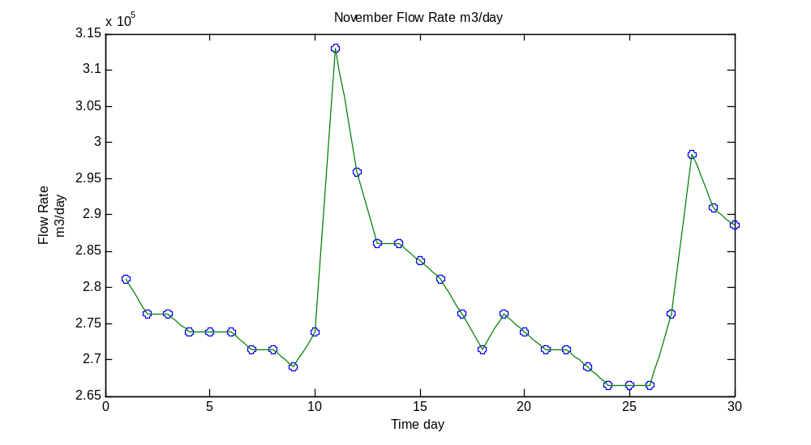
For December:
>> t12=linspace(1,31,31);
>> Q12=[288524.16, 290969.28, 288524.16, 293414.4, 293414.4, 295859.52, 295859.52, 290969.28, 286079.04, 288524.16, 293414.4, 332536.32, 352097.28, 322755.84, 327646.08, 310530.24, 303194.88, 298304.64, 290969.28, 288524.16, 286079.04, 327646.08, 378993.6, 325200.96, 310530.24, 303194.88, 298304.64, 298304.64, 295859.52, 290969.28, 295859.52];
>> tt12=linspace(1,31,151);
>> vl12=interp1(t12,Q12,tt12)
vl12 =
1.0e+005 *
Columns 1 through 7
2.8852 2.8901 2.8950 2.8999 2.9048 2.9097 2.9048
Columns 8 through 14
2.8999 2.8950 2.8901 2.8852 2.8950 2.9048 2.9146
Columns 15 through 21
2.9244 2.9341 2.9341 2.9341 2.9341 2.9341 2.9341
Columns 22 through 28
2.9390 2.9439 2.9488 2.9537 2.9586 2.9586 2.9586
Columns 29 through 35
2.9586 2.9586 2.9586 2.9488 2.9390 2.9293 2.9195
Columns 36 through 42
2.9097 2.8999 2.8901 2.8804 2.8706 2.8608 2.8657
Columns 43 through 49
2.8706 2.8755 2.8804 2.8852 2.8950 2.9048 2.9146
Columns 50 through 56
2.9244 2.9341 3.0124 3.0906 3.1689 3.2471 3.3254
Columns 57 through 63
3.3645 3.4036 3.4427 3.4819 3.5210 3.4623 3.4036
Columns 64 through 70
3.3449 3.2862 3.2276 3.2373 3.2471 3.2569 3.2667
Columns 71 through 77
3.2765 3.2422 3.2080 3.1738 3.1395 3.1053 3.0906
Columns 78 through 84
3.0760 3.0613 3.0466 3.0319 3.0222 3.0124 3.0026
Columns 85 through 91
2.9928 2.9830 2.9684 2.9537 2.9390 2.9244 2.9097
Columns 92 through 98
2.9048 2.8999 2.8950 2.8901 2.8852 2.8804 2.8755
Columns 99 through 105
2.8706 2.8657 2.8608 2.9439 3.0271 3.1102 3.1933
Columns 106 through 112
3.2765 3.3792 3.4819 3.5845 3.6872 3.7899 3.6824
Columns 113 through 119
3.5748 3.4672 3.3596 3.2520 3.2227 3.1933 3.1640
Columns 120 through 126
3.1346 3.1053 3.0906 3.0760 3.0613 3.0466 3.0319
Columns 127 through 133
3.0222 3.0124 3.0026 2.9928 2.9830 2.9830 2.9830
Columns 134 through 140
2.9830 2.9830 2.9830 2.9782 2.9733 2.9684 2.9635
Columns 141 through 147
2.9586 2.9488 2.9390 2.9293 2.9195 2.9097 2.9195
Columns 148 through 151
2.9293 2.9390 2.9488 2.9586
>> plot(t12,Q12,'o',tt12,vl12)
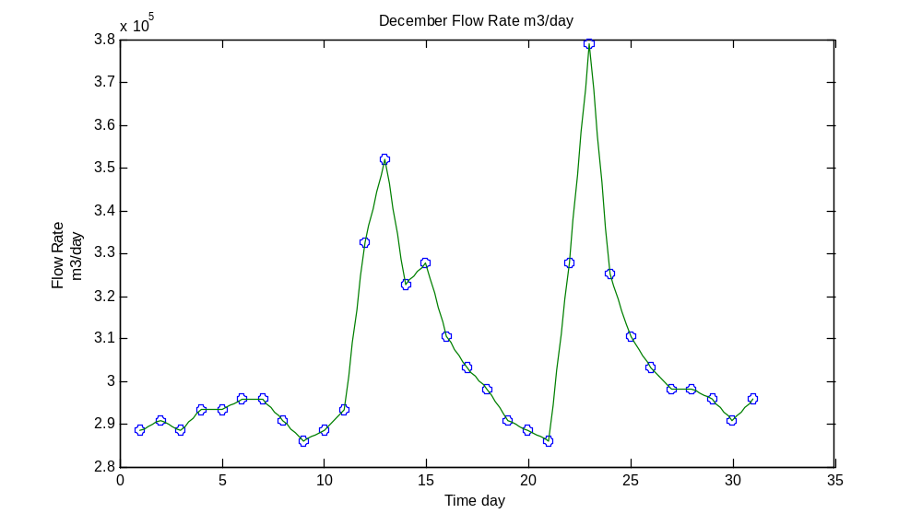
(b). Linear Interpolation applying step size t=0.5day
Using Matlab to solve:
For January:
>> t=linspace(1,31,31);
>> Q=[278743.68, 290969.28, 298304.64, 298304.64, 322755.84, 290969.28, 286079.04, 281188.8, 276298.56, 273853.44, 276298.56, 281188.8, 281188.8, 273853.44, 266518.08, 266518.08, 271408.32, 268963.2, 266518.08, 266518.08, 266518.08, 264072.96, 264072.96, 268963.2, 266518.08, 261627.84, 261627.84, 268963.2, 408335.04, 337426.56, 315420.48];
>> tt=linspace(1,31,151);
>> vl=interp1(t,Q,tt)
vl =
1.0e+005 *
Columns 1 through 7
2.7874 2.8486 2.9097 2.9464 2.9830 2.9830 2.9830
Columns 8 through 14
3.1053 3.2276 3.0686 2.9097 2.8852 2.8608 2.8363
Columns 15 through 21
2.8119 2.7874 2.7630 2.7508 2.7385 2.7508 2.7630
Columns 22 through 28
2.7874 2.8119 2.8119 2.8119 2.7752 2.7385 2.7019
Columns 29 through 35
2.6652 2.6652 2.6652 2.6896 2.7141 2.7019 2.6896
Columns 36 through 42
2.6774 2.6652 2.6652 2.6652 2.6652 2.6652 2.6530
Columns 43 through 49
2.6407 2.6407 2.6407 2.6652 2.6896 2.6774 2.6652
Columns 50 through 56
2.6407 2.6163 2.6163 2.6163 2.6530 2.6896 3.3865
Columns 57 through 61
4.0834 3.7288 3.3743 3.2642 3.1542
>> plot(t,Q,'o',tt,vl)
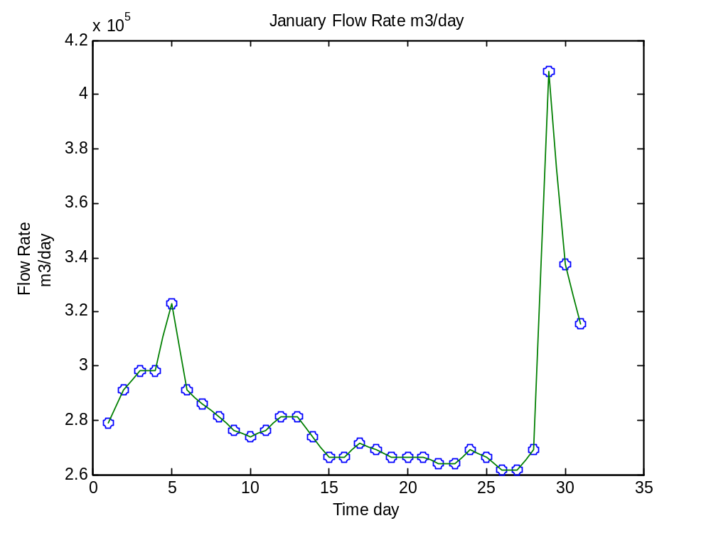
For February:
>> t2=linspace(1,28,28) ;
>> Q2=[308085.12, 305640, 300749.76, 303194.88, 308085.12, 300749.76, 295859.52, 290969.28, 286079.04, 286079.04, 283633.92, 283633.92, 283633.92, 283633.92, 288524.16, 293414.4, 298304.64, 278743.68, 283633.92, 283633.92, 286079.04, 283633.92, 283633.92, 281188.8, 281188.8, 278743.68, 278743.68, 273853.44] ;
>> tt2=linspace(1,28,55) ;
>> vl2=interp1(t2,Q2,tt2)
vl2 =
1.0e+005 *
Columns 1 through 7
3.0809 3.0686 3.0564 3.0319 3.0075 3.0197 3.0319
Columns 8 through 14
3.0564 3.0809 3.0442 3.0075 2.9830 2.9586 2.9341
Columns 15 through 21
2.9097 2.8852 2.8608 2.8608 2.8608 2.8486 2.8363
Columns 22 through 28
2.8363 2.8363 2.8363 2.8363 2.8363 2.8363 2.8608
Columns 29 through 35
2.8852 2.9097 2.9341 2.9586 2.9830 2.8852 2.7874
Columns 36 through 42
2.8119 2.8363 2.8363 2.8363 2.8486 2.8608 2.8486
Columns 43 through 49
2.8363 2.8363 2.8363 2.8241 2.8119 2.8119 2.8119
Columns 50 through 55
2.7997 2.7874 2.7874 2.7874 2.7630 2.7385
>> plot(t2,Q2,'o',tt2,vl2)
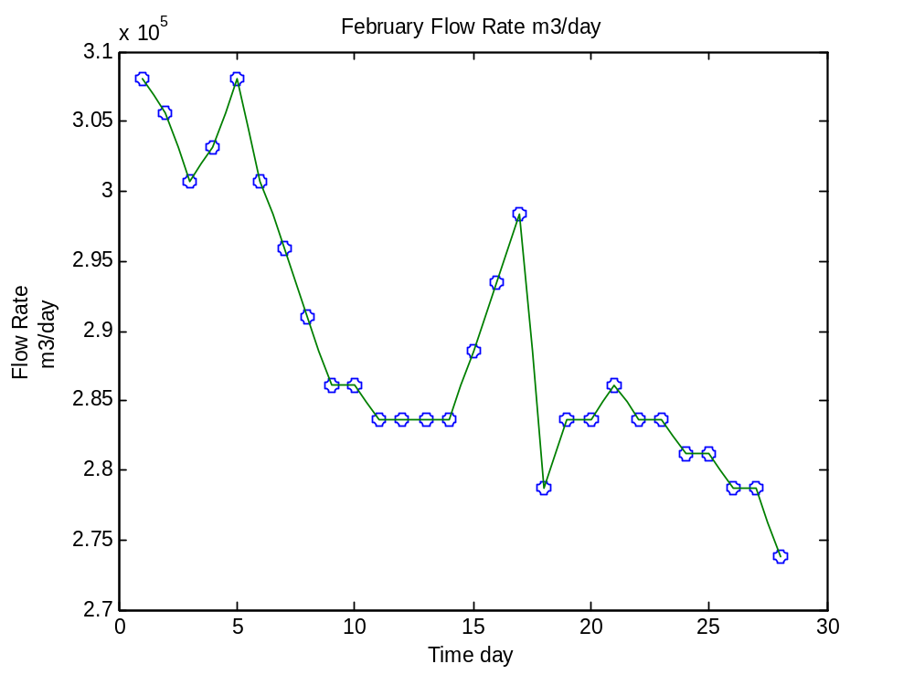
For March:
>> t3=linspace(1,31,31);
>> Q3=[273853.44, 278743.68, 276298.56, 276298.56, 276298.56, 276298.56, 273853.44, 281188.8, 300749.76, 334981.44, 327646.08, 356987.52, 398554.56, 339871.68, 312975.36, 305640, 300749.76, 295859.52, 295859.52, 293414.4, 290969.28, 293414.4, 293414.4, 293414.4, 293414.4, 293414.4, 290969.28, 290969.28, 290969.28, 293414.4, 298304.64];
>> tt3=linspace(1,31,61);
>> vl3=interp1(t3,Q3,tt3)
vl3 =
1.0e+005 *
Columns 1 through 7
2.7385 2.7630 2.7874 2.7752 2.7630 2.7630 2.7630
Columns 8 through 14
2.7630 2.7630 2.7630 2.7630 2.7508 2.7385 2.7752
Columns 15 through 21
2.8119 2.9097 3.0075 3.1787 3.3498 3.3131 3.2765
Columns 22 through 28
3.4232 3.5699 3.7777 3.9855 3.6921 3.3987 3.2642
Columns 29 through 35
3.1298 3.0931 3.0564 3.0319 3.0075 2.9830 2.9586
Columns 36 through 42
2.9586 2.9586 2.9464 2.9341 2.9219 2.9097 2.9219
Columns 43 through 49
2.9341 2.9341 2.9341 2.9341 2.9341 2.9341 2.9341
Columns 50 through 56
2.9341 2.9341 2.9219 2.9097 2.9097 2.9097 2.9097
Columns 57 through 61
2.9097 2.9219 2.9341 2.9586 2.9830
>> plot(t3,Q3,'o',tt3,vl3)
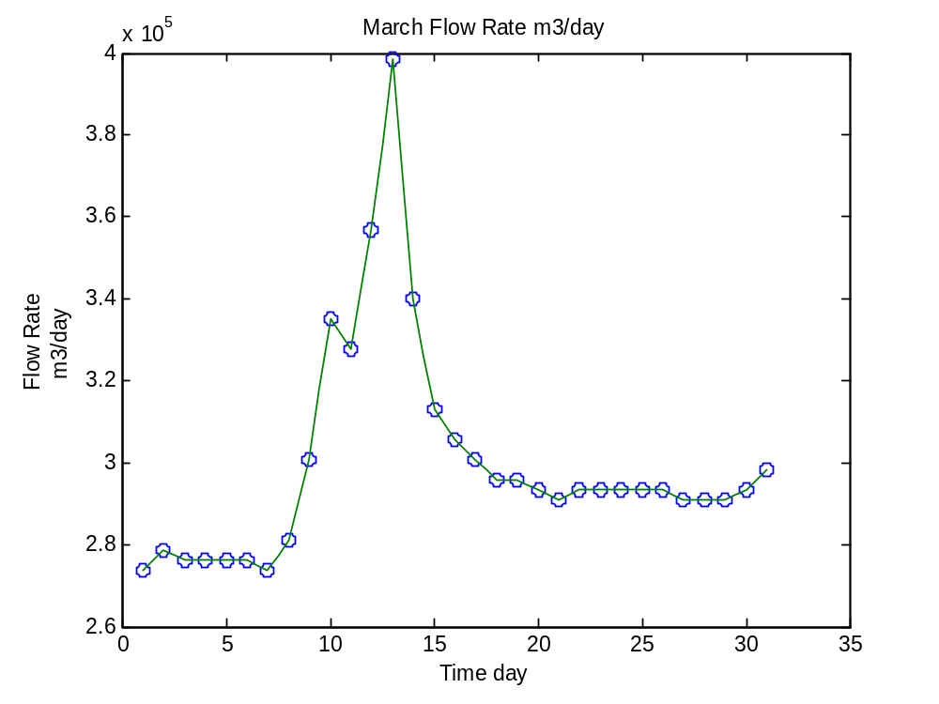
For April:
>> t4=linspace(1,30,30);
>> Q4=[298304.64, 288524.16, 398554.56, 30091.2, 305640, 298304.64, 293414.4, 288524.16, 286079.04, 286079.04, 283633.92, 293414.4, 288524.16, 286079.04, 281188.8, 278743.68, 273853.44, 273853.44, 271408.32, 271408.32, 268963.2, 271408.32, 303194.88, 288524.16, 283633.92, 278743.68, 273853.44, 268963.2, 268963.2, 266518.08];
>> tt4=linspace(1,30,59);
>> vl4=interp1(t4,Q4,tt4)
vl4 =
1.0e+005 *
Columns 1 through 7
2.9830 2.9341 2.8852 3.4354 3.9855 3.6432 3.3009
Columns 8 through 14
3.1787 3.0564 3.0197 2.9830 2.9586 2.9341 2.9097
Columns 15 through 21
2.8852 2.8730 2.8608 2.8608 2.8608 2.8486 2.8363
Columns 22 through 28
2.8852 2.9341 2.9097 2.8852 2.8730 2.8608 2.8363
Columns 29 through 35
2.8119 2.7997 2.7874 2.7630 2.7385 2.7385 2.7385
Columns 36 through 42
2.7263 2.7141 2.7141 2.7141 2.7019 2.6896 2.7019
Columns 43 through 49
2.7141 2.8730 3.0319 2.9586 2.8852 2.8608 2.8363
Columns 50 through 56
2.8119 2.7874 2.7630 2.7385 2.7141 2.6896 2.6896
Columns 57 through 59
2.6896 2.6774 2.6652
>> plot(t4,Q4,'o',tt4,vl4)
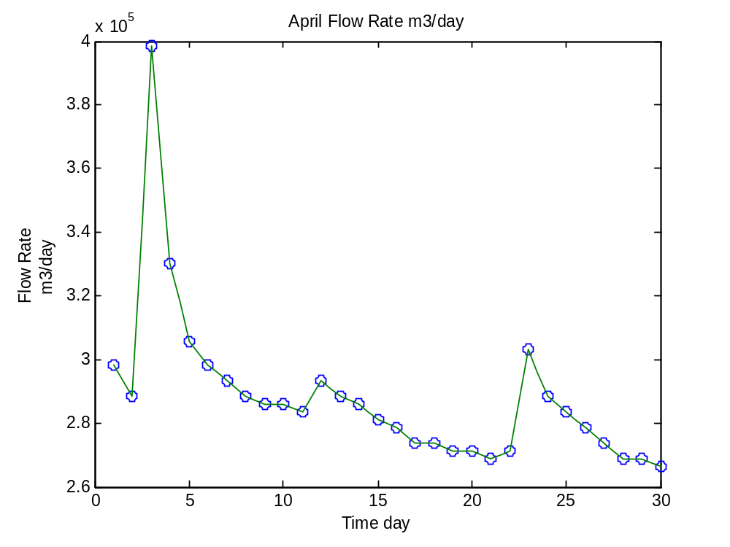
For May:
>> t5=linspace(1,31,31);
>> Q5=[266518.08, 286079.04, 286079.04, 273853.44, 271408.32, 268963.2, 268963.2, 266518.08, 261627.84, 276298.56, 442566.72, 354542.4, 315420.48, 308085.12, 303194.88, 300749.76, 298304.64, 308085.12, 303194.88, 295859.52, 295859.52, 290969.28, 288524.16, 286079.04, 286079.04, 288524.16, 286079.04, 315420.48, 300749.76, 293414.4, 300749.76] ;
>> tt5=linspace(1,31,61)
>> vl5=interp1(t5,Q5,tt5)
vl5 =
1.0e+005 *
Columns 1 through 7
2.6652 2.7630 2.8608 2.8608 2.8608 2.7997 2.7385
Columns 8 through 14
2.7263 2.7141 2.7019 2.6896 2.6896 2.6896 2.6774
Columns 15 through 21
2.6652 2.6407 2.6163 2.6896 2.7630 3.5943 4.4257
Columns 22 through 28
3.9855 3.5454 3.3498 3.1542 3.1175 3.0809 3.0564
Columns 29 through 35
3.0319 3.0197 3.0075 2.9953 2.9830 3.0319 3.0809
Columns 36 through 42
3.0564 3.0319 2.9953 2.9586 2.9586 2.9586 2.9341
Columns 43 through 49
2.9097 2.8975 2.8852 2.8730 2.8608 2.8608 2.8608
Columns 50 through 56
2.8730 2.8852 2.8730 2.8608 3.0075 3.1542 3.0809
Columns 57 through 61
3.0075 2.9708 2.9341 2.9708 3.0075
>> plot(t5,Q5,'o',tt5,vl5)
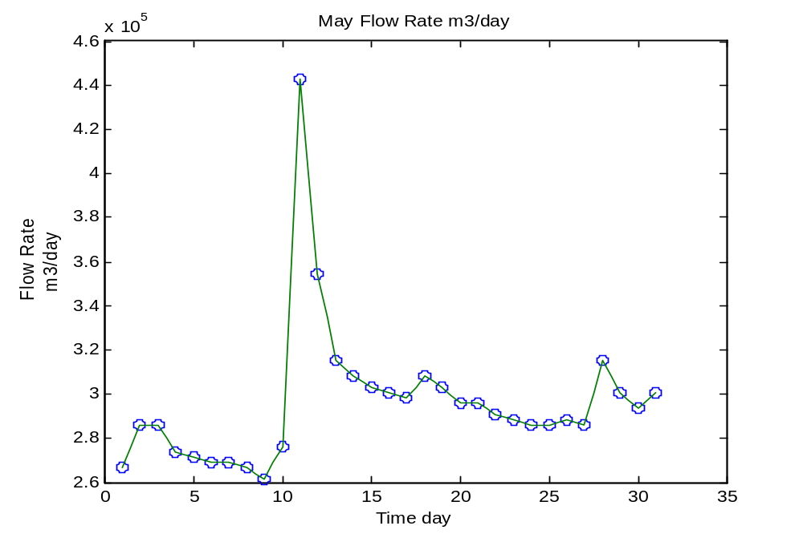
For June:
>> t6=linspace(1,30,30);
>>Q6=[293414.4, 288524.16, 286079.04, 283633.92, 281188.8, 283633.92, 327646.08, 298304.64, 288524.16, 283633.92, 281188.8, 278743.68, 276298.56, 276298.56, 271408.32, 271408.32, 266518.08, 281188.8, 276298.56, 271408.32, 283633.92, 276298.56, 268963.2, 266518.08, 271408.32, 271408.32, 271408.32, 266518.08, 266518.08, 271408.32];
>> tt6=linspace(1,30,59);
>> vl6=interp1(t6,Q6,tt6)
vl6 =
1.0e+005 *
Columns 1 through 7
2.9341 2.9097 2.8852 2.8730 2.8608 2.8486 2.8363
Columns 8 through 14
2.8241 2.8119 2.8241 2.8363 3.0564 3.2765 3.1298
Columns 15 through 21
2.9830 2.9341 2.8852 2.8608 2.8363 2.8241 2.8119
Columns 22 through 28
2.7997 2.7874 2.7752 2.7630 2.7630 2.7630 2.7385
Columns 29 through 35
2.7141 2.7141 2.7141 2.6896 2.6652 2.7385 2.8119
Columns 36 through 42
2.7874 2.7630 2.7385 2.7141 2.7752 2.8363 2.7997
Columns 43 through 49
2.7630 2.7263 2.6896 2.6774 2.6652 2.6896 2.7141
Columns 50 through 56
2.7141 2.7141 2.7141 2.7141 2.6896 2.6652 2.6652
Columns 57 through 59
2.6652 2.6896 2.7141
>> plot(t6,Q6,'o',tt6,vl6)
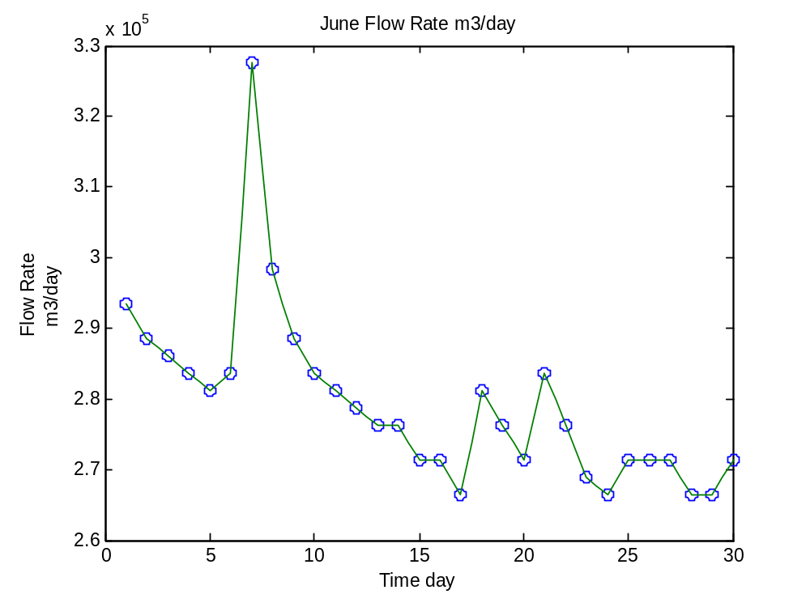
For July:
>> t7=linspace(1,31,31);
>> Q7=[268963.2, 268963.2, 266518.08, 268963.2, 264072.96, 264072.96, 266518.08, 261627.84, 273853.44, 281188.8, 271408.32, 268963.2, 264072.96, 264072.96, 264072.96, 261627.84, 276298.56, 283633.92, 271408.32, 276298.56, 271408.32, 268963.2, 266518.08, 298304.64, 276298.56, 330091.2, 293414.4, 283633.92, 278743.68, 278743.68, 276298.56];
>> tt7=linspace(1,31,61);
>> vl7=interp1(t7,Q7,tt7)
vl7 =
1.0e+005 *
Columns 1 through 7
2.6896 2.6896 2.6896 2.6774 2.6652 2.6774 2.6896
Columns 8 through 14
2.6652 2.6407 2.6407 2.6407 2.6530 2.6652 2.6407
Columns 15 through 21
2.6163 2.6774 2.7385 2.7752 2.8119 2.7630 2.7141
Columns 22 through 28
2.7019 2.6896 2.6652 2.6407 2.6407 2.6407 2.6407
Columns 29 through 35
2.6407 2.6285 2.6163 2.6896 2.7630 2.7997 2.8363
Columns 36 through 42
2.7752 2.7141 2.7385 2.7630 2.7385 2.7141 2.7019
Columns 43 through 49
2.6896 2.6774 2.6652 2.8241 2.9830 2.8730 2.7630
Columns 50 through 56
3.0319 3.3009 3.1175 2.9341 2.8852 2.8363 2.8119
Columns 57 through 61
2.7874 2.7874 2.7874 2.7752 2.7630
>> plot(t7,Q7,'o',tt7,vl7)
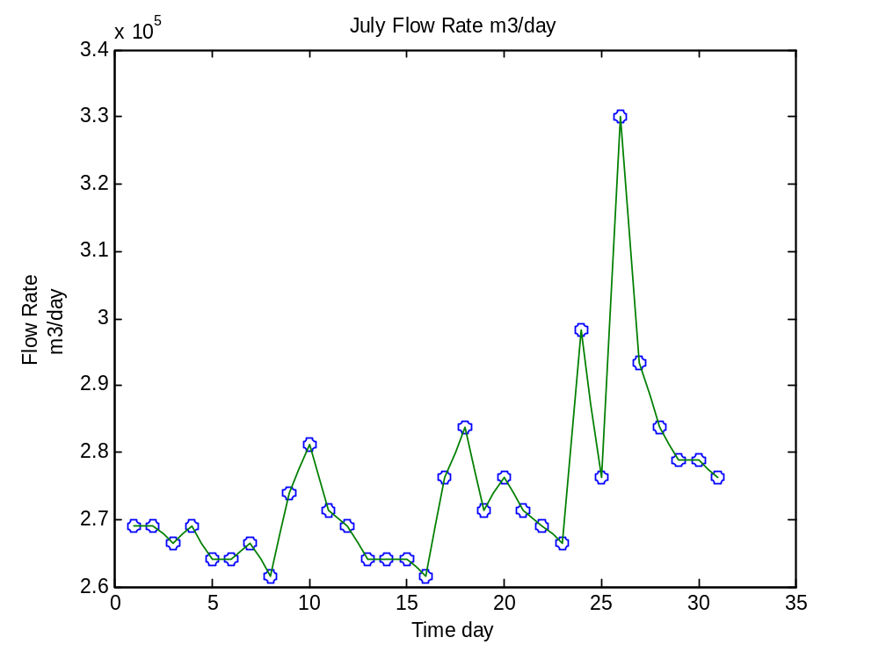
For August:
>> t8=linspace(1,31,31);
>> Q8=[276298.56, 364322.88, 305640, 293414.4, 286079.04, 286079.04, 283633.92, 281188.8, 278743.68, 281188.8, 278743.68, 273853.44, 273853.44, 276298.56, 273853.44, 271408.32, 273853.44, 273853.44, 276298.56, 276298.56, 271408.32, 271408.32, 276298.56, 281188.8, 359432.64, 315420.48, 308085.12, 300749.76, 298304.64, 293414.4, 288524.16];
>> tt8=linspace(1,31,61);
>> vl8=interp1(t8,Q8,tt8)
vl8 =
1.0e+005 *
Columns 1 through 7
2.7630 3.2031 3.6432 3.3498 3.0564 2.9953 2.9341
Columns 8 through 14
2.8975 2.8608 2.8608 2.8608 2.8486 2.8363 2.8241
Columns 15 through 21
2.8119 2.7997 2.7874 2.7997 2.8119 2.7997 2.7874
Columns 22 through 28
2.7630 2.7385 2.7385 2.7385 2.7508 2.7630 2.7508
Columns 29 through 35
2.7385 2.7263 2.7141 2.7263 2.7385 2.7385 2.7385
Columns 36 through 42
2.7508 2.7630 2.7630 2.7630 2.7385 2.7141 2.7141
Columns 43 through 49
2.7141 2.7385 2.7630 2.7874 2.8119 3.2031 3.5943
Columns 50 through 56
3.3743 3.1542 3.1175 3.0809 3.0442 3.0075 2.9953
Columns 57 through 61
2.9830 2.9586 2.9341 2.9097 2.8852
>> plot(t8,Q8,'o',tt8,vl8)
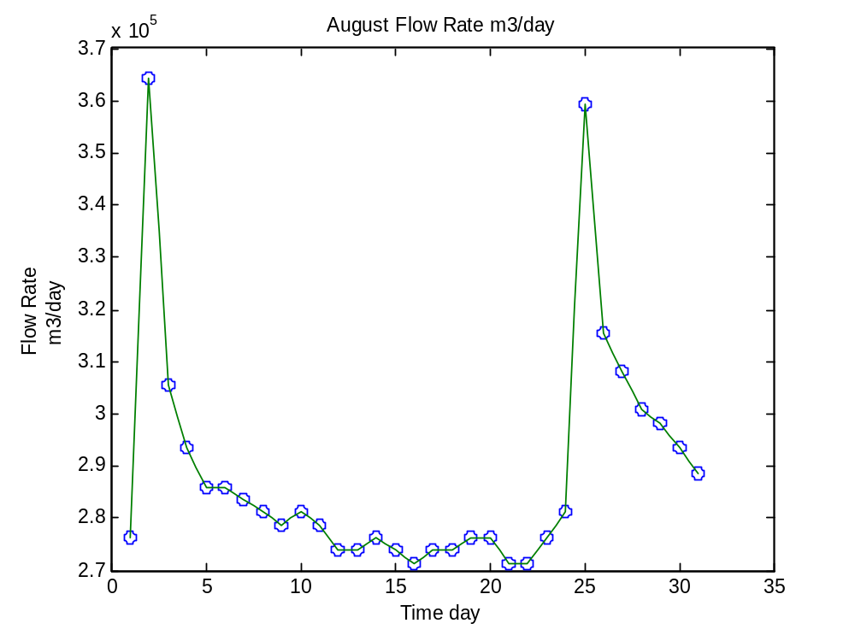
For September:
>> t9=linspace(1,30,30);
>> Q9=[286079.04, 286079.04, 286079.04, 286079.04, 283633.92, 278743.68, 276298.56, 276298.56, 290969.28, 281188.8, 281188.8, 339871.68, 308085.12, 300749.76, 293414.4, 290969.28, 290969.28, 308085.12, 298304.64, 293414.4, 288524.16, 286079.04, 290969.28, 312975.36, 293414.4, 288524.16, 315420.48, 308085.12, 305640, 310530.24];
>> tt9=linspace(1,30,59);
>> vl9=interp1(t9,Q9,tt9)
vl9 =
1.0e+005 *
Columns 1 through 7
2.8608 2.8608 2.8608 2.8608 2.8608 2.8608 2.8608
Columns 8 through 14
2.8486 2.8363 2.8119 2.7874 2.7752 2.7630 2.7630
Columns 15 through 21
2.7630 2.8363 2.9097 2.8608 2.8119 2.8119 2.8119
Columns 22 through 28
3.1053 3.3987 3.2398 3.0809 3.0442 3.0075 2.9708
Columns 29 through 35
2.9341 2.9219 2.9097 2.9097 2.9097 2.9953 3.0809
Columns 36 through 42
3.0319 2.9830 2.9586 2.9341 2.9097 2.8852 2.8730
Columns 43 through 49
2.8608 2.8852 2.9097 3.0197 3.1298 3.0319 2.9341
Columns 50 through 56
2.9097 2.8852 3.0197 3.1542 3.1175 3.0809 3.0686
Columns 57 through 59
3.0564 3.0809 3.1053
>> plot(t9,Q9,'o',tt9,vl9)
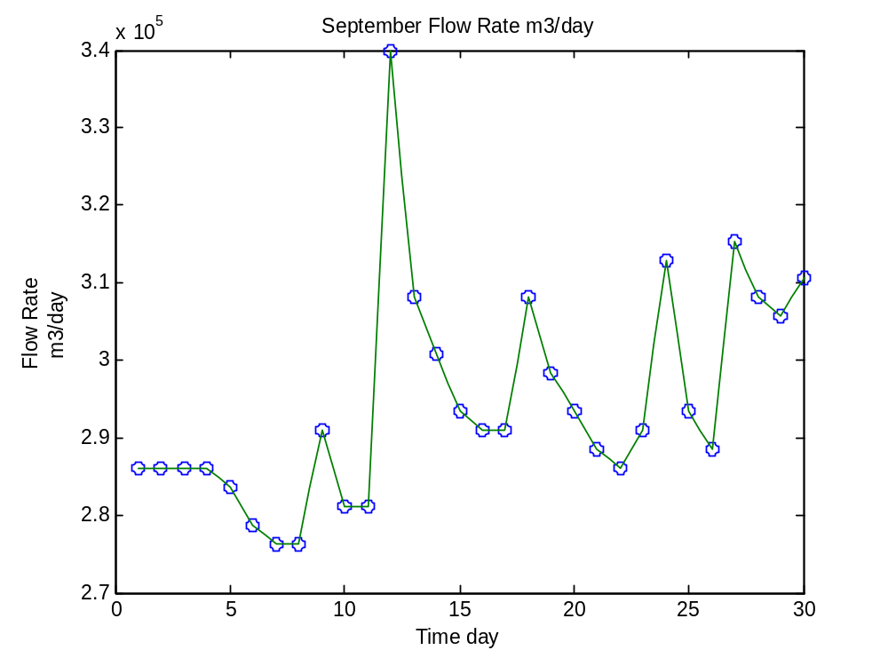
For October:
>> t10=linspace(1,31,31);
>> Q10=[295859.52, 288524.16, 283633.92, 484133.76, 322755.84, 305640, 298304.64, 290969.28, 286079.04, 286079.04, 342316.8, 359432.64, 347207.04, 342316.8, 315420.48, 305640, 347207.04, 325200.96, 322755.84, 310530.24, 303194.88, 366768, 330091.2, 317865.6, 308085.12, 298304.64, 293414.4, 317865.6, 295859.52, 288524.16, 283633.92];
>> tt10=linspace(1,31,61);
>> vl10=interp1(t10,Q10,tt10)
vl10 =
1.0e+005 *
Columns 1 through 7
2.9586 2.9219 2.8852 2.8608 2.8363 3.8388 4.8413
Columns 8 through 14
4.0344 3.2276 3.1420 3.0564 3.0197 2.9830 2.9464
Columns 15 through 21
2.9097 2.8852 2.8608 2.8608 2.8608 3.1420 3.4232
Columns 22 through 28
3.5087 3.5943 3.5332 3.4721 3.4476 3.4232 3.2887
Columns 29 through 35
3.1542 3.1053 3.0564 3.2642 3.4721 3.3620 3.2520
Columns 36 through 42
3.2398 3.2276 3.1664 3.1053 3.0686 3.0319 3.3498
Columns 43 through 49
3.6677 3.4843 3.3009 3.2398 3.1787 3.1298 3.0809
Columns 50 through 56
3.0319 2.9830 2.9586 2.9341 3.0564 3.1787 3.0686
Columns 57 through 61
2.9586 2.9219 2.8852 2.8608 2.8363
>> plot(t10,Q10,'o',tt10,vl10)
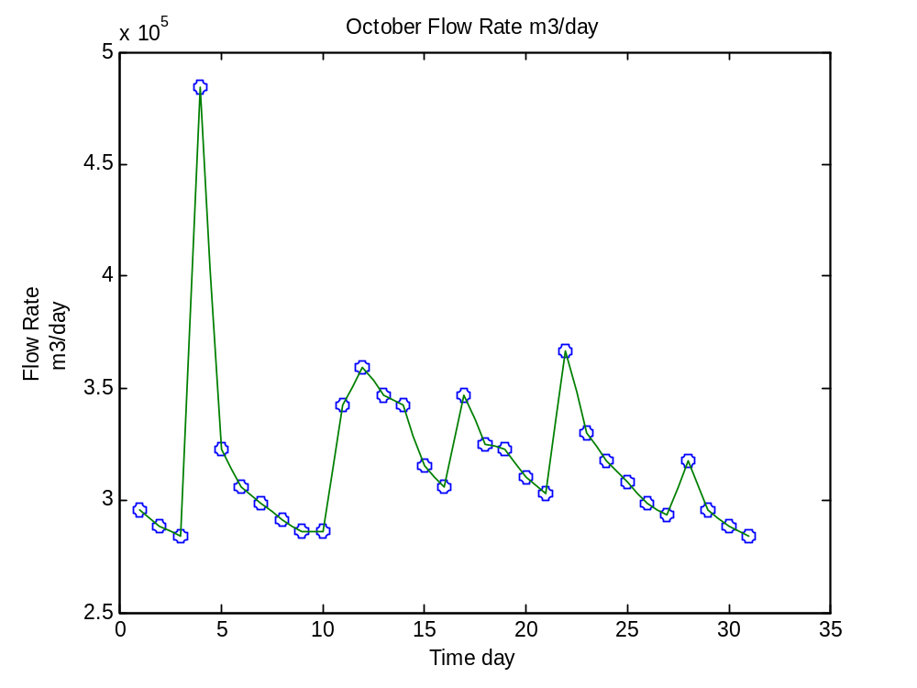
For November:
>> t11=linspace(1,30,30);
>> Q11=[281188.8, 276298.56, 276298.56, 273853.44, 273853.44, 273853.44, 271408.32, 271408.32, 268963.2, 273853.44, 312975.36, 295859.52, 286079.04, 286079.04, 283633.92, 281188.8, 276298.56, 271408.32, 276298.56, 273853.44, 271408.32, 271408.32, 268963.2, 266518.08, 266518.08, 266518.08, 276298.56, 298304.64, 290969.28, 288524.16];
>> tt11=linspace(1,30,59);
>> vl11=interp1(t11,Q11,tt11)
vl11 =
1.0e+005 *
Columns 1 through 7
2.8119 2.7874 2.7630 2.7630 2.7630 2.7508 2.7385
Columns 8 through 14
2.7385 2.7385 2.7385 2.7385 2.7263 2.7141 2.7141
Columns 15 through 21
2.7141 2.7019 2.6896 2.7141 2.7385 2.9341 3.1298
Columns 22 through 28
3.0442 2.9586 2.9097 2.8608 2.8608 2.8608 2.8486
Columns 29 through 35
2.8363 2.8241 2.8119 2.7874 2.7630 2.7385 2.7141
Columns 36 through 42
2.7385 2.7630 2.7508 2.7385 2.7263 2.7141 2.7141
Columns 43 through 49
2.7141 2.7019 2.6896 2.6774 2.6652 2.6652 2.6652
Columns 50 through 56
2.6652 2.6652 2.7141 2.7630 2.8730 2.9830 2.9464
Columns 57 through 59
2.9097 2.8975 2.8852
>> plot(t11,Q11,'o',tt11,vl11)
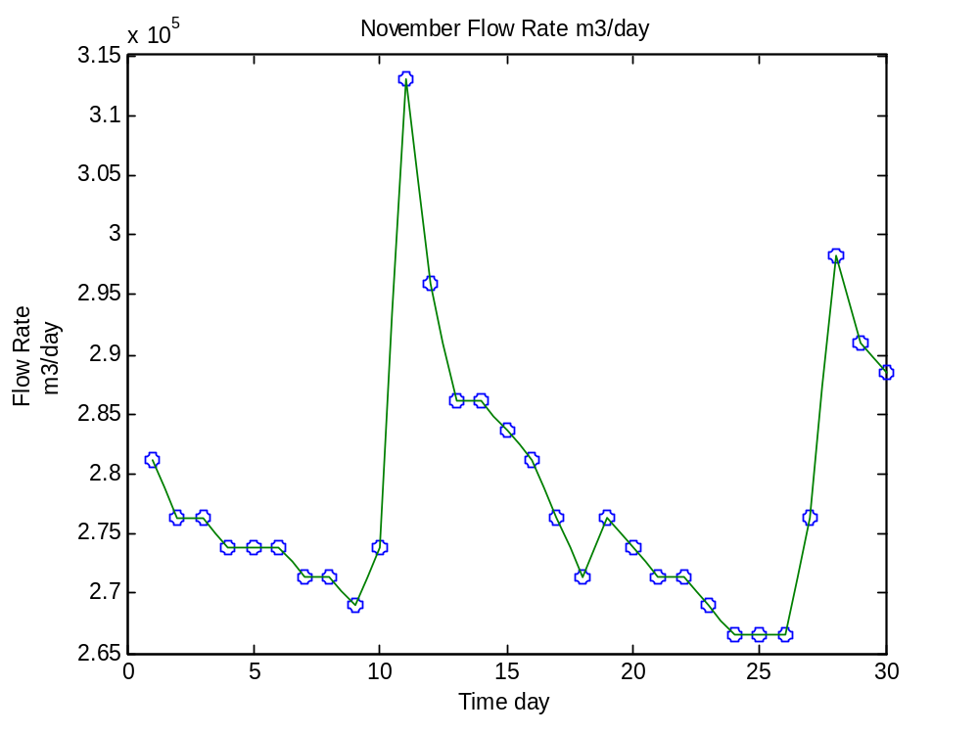
For December:
>> t12=linspace(1,31,31);
>> Q12=[288524.16, 290969.28, 288524.16, 293414.4, 293414.4, 295859.52, 295859.52, 290969.28, 286079.04, 288524.16, 293414.4, 332536.32, 352097.28, 322755.84, 327646.08, 310530.24, 303194.88, 298304.64, 290969.28, 288524.16, 286079.04, 327646.08, 378993.6, 325200.96, 310530.24, 303194.88, 298304.64, 298304.64, 295859.52, 290969.28, 295859.52];
>> tt12=linspace(1,31,61);
>> vl12=interp1(t12,Q12,tt12)
vl12 =
1.0e+005 *
Columns 1 through 7
2.8852 2.8975 2.9097 2.8975 2.8852 2.9097 2.9341
Columns 8 through 14
2.9341 2.9341 2.9464 2.9586 2.9586 2.9586 2.9341
Columns 15 through 21
2.9097 2.8852 2.8608 2.8730 2.8852 2.9097 2.9341
Columns 22 through 28
3.1298 3.3254 3.4232 3.5210 3.3743 3.2276 3.2520
Columns 29 through 35
3.2765 3.1909 3.1053 3.0686 3.0319 3.0075 2.9830
Columns 36 through 42
2.9464 2.9097 2.8975 2.8852 2.8730 2.8608 3.0686
Columns 43 through 49
3.2765 3.5332 3.7899 3.5210 3.2520 3.1787 3.1053
Columns 50 through 56
3.0686 3.0319 3.0075 2.9830 2.9830 2.9830 2.9708
Columns 57 through 61
2.9586 2.9341 2.9097 2.9341 2.9586
>> plot(t12,Q12,'o',tt12,vl12)
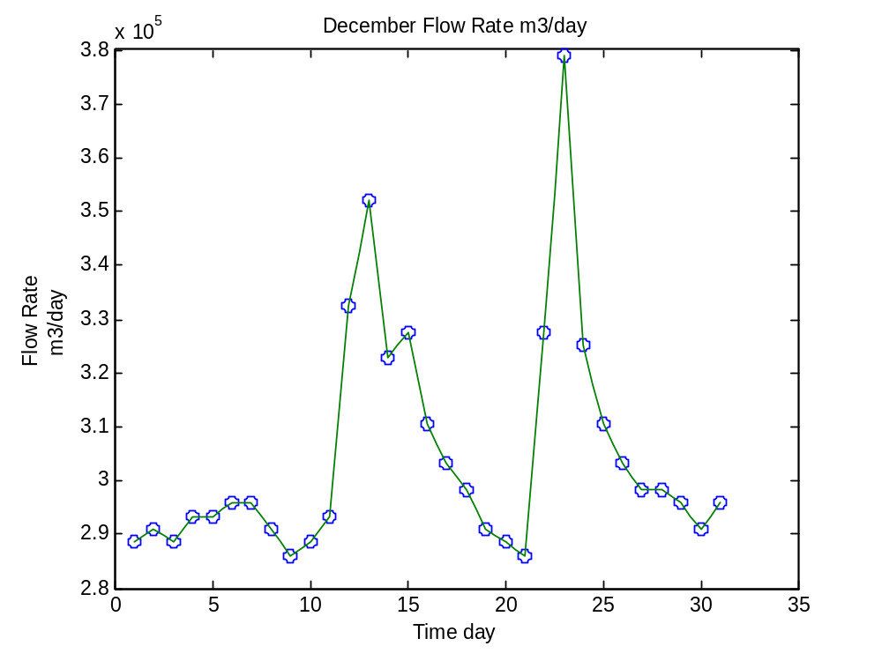

(a). Linear Interpolation applying step size t=0.2day
Using Matlab to solve:
For January:
>> t=linspace(1,31,31);
>> W=[4353.333333, 4361.46, 4369.523333, 4377.586667, 4385.65, 4393.713333, 4401.776667, 4409.84, 4417.903333, 4425.966667, 4434.03, 4442.093333, 4450.156667, 4458.22, 4466.283333, 4474.346667, 4482.41, 4490.473333, 4498.536667, 4506.6, 4514.663333, 4522.726667, 4530.79, 4538.853333, 4546.916667, 4554.98, 4563.043333, 4571.106667, 4579.17, 4587.233333, 4595.296667];
>> tt=linspace(1,31,151);
>> vll=interp1(t,W,tt)
vll =
1.0e+003 *
Columns 1 through 7
4.3533 4.3550 4.3566 4.3582 4.3598 4.3615 4.3631
Columns 8 through 14
4.3647 4.3663 4.3679 4.3695 4.3711 4.3727 4.3744
Columns 15 through 21
4.3760 4.3776 4.3792 4.3808 4.3824 4.3840 4.3857
Columns 22 through 28
4.3873 4.3889 4.3905 4.3921 4.3937 4.3953 4.3969
Columns 29 through 35
4.3986 4.4002 4.4018 4.4034 4.4050 4.4066 4.4082
Columns 36 through 42
4.4098 4.4115 4.4131 4.4147 4.4163 4.4179 4.4195
Columns 43 through 49
4.4211 4.4227 4.4244 4.4260 4.4276 4.4292 4.4308
Columns 50 through 56
4.4324 4.4340 4.4356 4.4373 4.4389 4.4405 4.4421
Columns 57 through 63
4.4437 4.4453 4.4469 4.4485 4.4502 4.4518 4.4534
Columns 64 through 70
4.4550 4.4566 4.4582 4.4598 4.4614 4.4631 4.4647
Columns 71 through 77
4.4663 4.4679 4.4695 4.4711 4.4727 4.4743 4.4760
Columns 78 through 84
4.4776 4.4792 4.4808 4.4824 4.4840 4.4856 4.4872
Columns 85 through 91
4.4889 4.4905 4.4921 4.4937 4.4953 4.4969 4.4985
Columns 92 through 98
4.5001 4.5018 4.5034 4.5050 4.5066 4.5082 4.5098
Columns 99 through 105
4.5114 4.5131 4.5147 4.5163 4.5179 4.5195 4.5211
Columns 106 through 112
4.5227 4.5243 4.5260 4.5276 4.5292 4.5308 4.5324
Columns 113 through 119
4.5340 4.5356 4.5372 4.5389 4.5405 4.5421 4.5437
Columns 120 through 126
4.5453 4.5469 4.5485 4.5501 4.5518 4.5534 4.5550
Columns 127 through 133
4.5566 4.5582 4.5598 4.5614 4.5630 4.5647 4.5663
Columns 134 through 140
4.5679 4.5695 4.5711 4.5727 4.5743 4.5759 4.5776
Columns 141 through 147
4.5792 4.5808 4.5824 4.5840 4.5856 4.5872 4.5888
Columns 148 through 151
4.5905 4.5921 4.5937 4.5953
>> plot(t,W,'o',tt,vll)
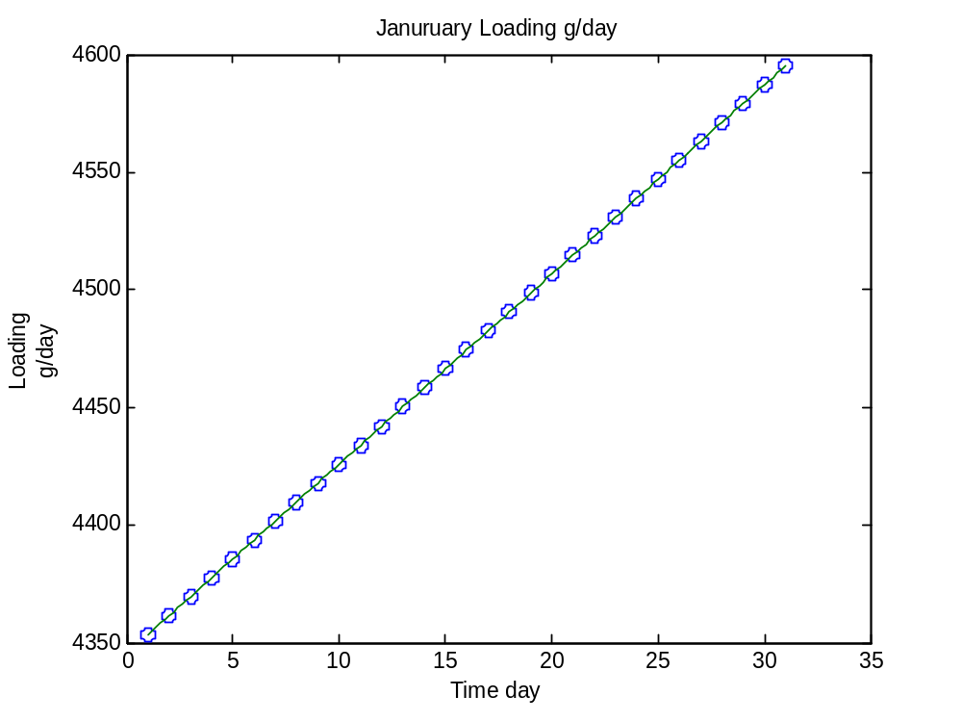
For February:
>> t2=linspace(1,28,28);
>> W2=[4603.333333, 4645.16, 4686.946667, 4728.733333, 4770.52, 4812.306667, 4854.093333, 4895.88, 4937.666667, 4979.453333, 5021.24, 5063.026667, 5104.813333, 5146.6, 5188.386667, 5230.173333, 5271.96, 5313.746667, 5355.533333, 5397.32, 5439.106667, 5480.893333, 5522.68, 5564.466667, 5606.253333, 5648.04, 5689.826667, 5731.613333];
>> tt2=linspace(1,28,136)
>> vll2=interp1(t2,W2,tt2)
vll2 =
1.0e+003 *
Columns 1 through 7
4.6033 4.6117 4.6201 4.6284 4.6368 4.6452 4.6535
Columns 8 through 14
4.6619 4.6702 4.6786 4.6869 4.6953 4.7037 4.7120
Columns 15 through 21
4.7204 4.7287 4.7371 4.7454 4.7538 4.7622 4.7705
Columns 22 through 28
4.7789 4.7872 4.7956 4.8039 4.8123 4.8207 4.8290
Columns 29 through 35
4.8374 4.8457 4.8541 4.8625 4.8708 4.8792 4.8875
Columns 36 through 42
4.8959 4.9042 4.9126 4.9210 4.9293 4.9377 4.9460
Columns 43 through 49
4.9544 4.9627 4.9711 4.9795 4.9878 4.9962 5.0045
Columns 50 through 56
5.0129 5.0212 5.0296 5.0380 5.0463 5.0547 5.0630
Columns 57 through 63
5.0714 5.0797 5.0881 5.0965 5.1048 5.1132 5.1215
Columns 64 through 70
5.1299 5.1382 5.1466 5.1550 5.1633 5.1717 5.1800
Columns 71 through 77
5.1884 5.1967 5.2051 5.2135 5.2218 5.2302 5.2385
Columns 78 through 84
5.2469 5.2552 5.2636 5.2720 5.2803 5.2887 5.2970
Columns 85 through 91
5.3054 5.3137 5.3221 5.3305 5.3388 5.3472 5.3555
Columns 92 through 98
5.3639 5.3722 5.3806 5.3890 5.3973 5.4057 5.4140
Columns 99 through 105
5.4224 5.4307 5.4391 5.4475 5.4558 5.4642 5.4725
Columns 106 through 112
5.4809 5.4893 5.4976 5.5060 5.5143 5.5227 5.5310
Columns 113 through 119
5.5394 5.5478 5.5561 5.5645 5.5728 5.5812 5.5895
Columns 120 through 126
5.5979 5.6063 5.6146 5.6230 5.6313 5.6397 5.6480
Columns 127 through 133
5.6564 5.6648 5.6731 5.6815 5.6898 5.6982 5.7065
Columns 134 through 136
5.7149 5.7233 5.7316
>> plot(t2,W2,'o',tt2,vll2)
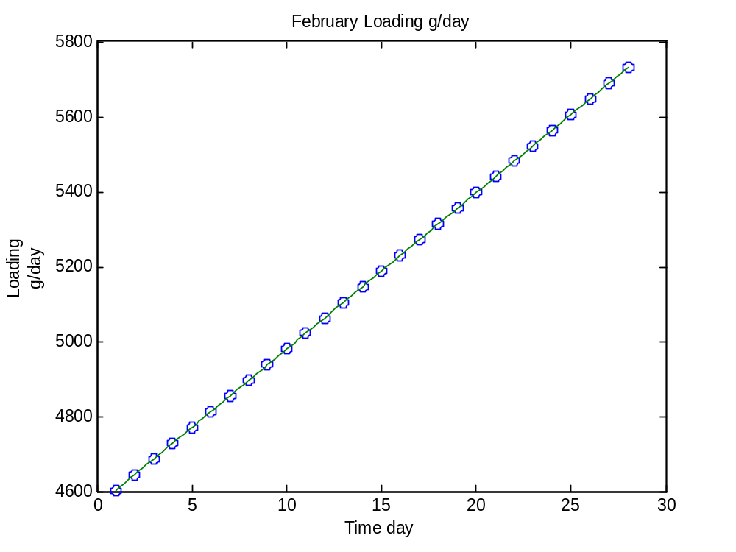
For March:
>> t3=linspace(1,31,31);
>> W3=[5773.333333, 5829.29, 5885.18, 5941.07, 5996.96, 6052.85, 6108.74, 6164.63, 6220.52, 6276.41, 6332.3, 6388.19, 6444.08, 6499.97, 6555.86, 6611.75, 6667.64, 6723.53, 6779.42, 6835.31, 6891.2, 6947.09, 7002.98, 7058.87, 7114.76, 7170.65, 7226.54, 7282.43, 7338.32, 7394.21, 7450];
>> tt3=linspace(1,31,151);
>> vll3=interp1(t3,W3,tt3)
vll3 =
1.0e+003 *
Columns 1 through 7
5.7733 5.7845 5.7957 5.8069 5.8181 5.8293 5.8405
Columns 8 through 14
5.8516 5.8628 5.8740 5.8852 5.8964 5.9075 5.9187
Columns 15 through 21
5.9299 5.9411 5.9522 5.9634 5.9746 5.9858 5.9970
Columns 22 through 28
6.0081 6.0193 6.0305 6.0417 6.0529 6.0640 6.0752
Columns 29 through 35
6.0864 6.0976 6.1087 6.1199 6.1311 6.1423 6.1535
Columns 36 through 42
6.1646 6.1758 6.1870 6.1982 6.2093 6.2205 6.2317
Columns 43 through 49
6.2429 6.2541 6.2652 6.2764 6.2876 6.2988 6.3099
Columns 50 through 56
6.3211 6.3323 6.3435 6.3547 6.3658 6.3770 6.3882
Columns 57 through 63
6.3994 6.4105 6.4217 6.4329 6.4441 6.4553 6.4664
Columns 64 through 70
6.4776 6.4888 6.5000 6.5111 6.5223 6.5335 6.5447
Columns 71 through 77
6.5559 6.5670 6.5782 6.5894 6.6006 6.6117 6.6229
Columns 78 through 84
6.6341 6.6453 6.6565 6.6676 6.6788 6.6900 6.7012
Columns 85 through 91
6.7124 6.7235 6.7347 6.7459 6.7571 6.7682 6.7794
Columns 92 through 98
6.7906 6.8018 6.8130 6.8241 6.8353 6.8465 6.8577
Columns 99 through 105
6.8688 6.8800 6.8912 6.9024 6.9136 6.9247 6.9359
Columns 106 through 112
6.9471 6.9583 6.9694 6.9806 6.9918 7.0030 7.0142
Columns 113 through 119
7.0253 7.0365 7.0477 7.0589 7.0700 7.0812 7.0924
Columns 120 through 126
7.1036 7.1148 7.1259 7.1371 7.1483 7.1595 7.1706
Columns 127 through 133
7.1818 7.1930 7.2042 7.2154 7.2265 7.2377 7.2489
Columns 134 through 140
7.2601 7.2713 7.2824 7.2936 7.3048 7.3160 7.3271
Columns 141 through 147
7.3383 7.3495 7.3607 7.3719 7.3830 7.3942 7.4054
Columns 148 through 151
7.4165 7.4277 7.4388 7.4500
>> plot(t3,W3,'o',tt3,vll3)
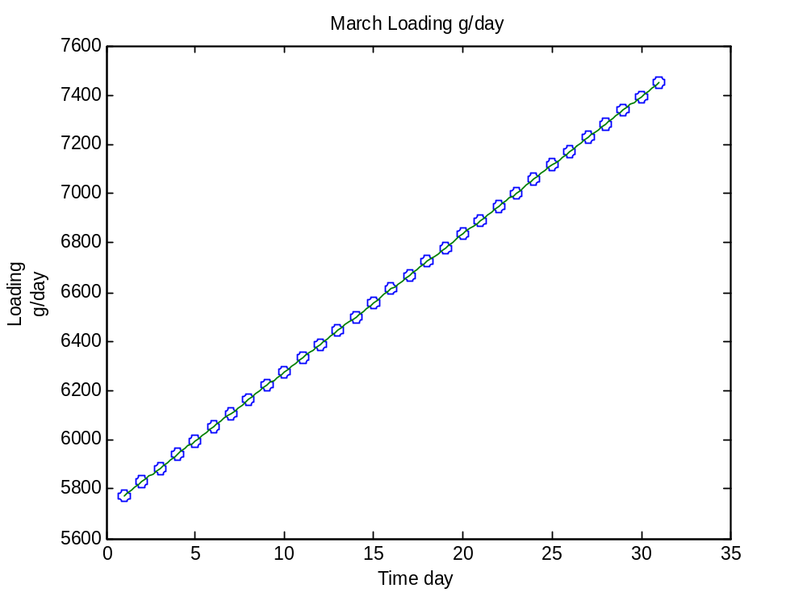
For April:
>> t4=linspace(1,30,30);
>> W4=[7419.576667, 7389.253333, 7358.93, 7328.606667, 7298.283333, 7267.96, 7237.636667, 7207.313333, 7176.99, 7146.666667, 7116.343333, 7086.02, 7055.696667, 7025.373333, 6995.05, 6964.726667, 6934.403333, 6904.08, 6873.756667, 6843.433333, 6813.11, 6782.786667, 6752.463333, 6722.14, 6691.816667, 6661.493333, 6631.17, 6600.846667, 6570.523333, 6540.2];
>> tt4=linspace(1,30,146);
>> vll4=interp1(t4,W4,tt4)
vll4 =
1.0e+003 *
Columns 1 through 7
7.4196 7.4135 7.4074 7.4014 7.3953 7.3893 7.3832
Columns 8 through 14
7.3771 7.3711 7.3650 7.3589 7.3529 7.3468 7.3407
Columns 15 through 21
7.3347 7.3286 7.3225 7.3165 7.3104 7.3043 7.2983
Columns 22 through 28
7.2922 7.2862 7.2801 7.2740 7.2680 7.2619 7.2558
Columns 29 through 35
7.2498 7.2437 7.2376 7.2316 7.2255 7.2194 7.2134
Columns 36 through 42
7.2073 7.2012 7.1952 7.1891 7.1831 7.1770 7.1709
Columns 43 through 49
7.1649 7.1588 7.1527 7.1467 7.1406 7.1345 7.1285
Columns 50 through 56
7.1224 7.1163 7.1103 7.1042 7.0981 7.0921 7.0860
Columns 57 through 63
7.0800 7.0739 7.0678 7.0618 7.0557 7.0496 7.0436
Columns 64 through 70
7.0375 7.0314 7.0254 7.0193 7.0132 7.0072 7.0011
Columns 71 through 77
6.9951 6.9890 6.9829 6.9769 6.9708 6.9647 6.9587
Columns 78 through 84
6.9526 6.9465 6.9405 6.9344 6.9283 6.9223 6.9162
Columns 85 through 91
6.9101 6.9041 6.8980 6.8920 6.8859 6.8798 6.8738
Columns 92 through 98
6.8677 6.8616 6.8556 6.8495 6.8434 6.8374 6.8313
Columns 99 through 105
6.8252 6.8192 6.8131 6.8070 6.8010 6.7949 6.7889
Columns 106 through 112
6.7828 6.7767 6.7707 6.7646 6.7585 6.7525 6.7464
Columns 113 through 119
6.7403 6.7343 6.7282 6.7221 6.7161 6.7100 6.7039
Columns 120 through 126
6.6979 6.6918 6.6858 6.6797 6.6736 6.6676 6.6615
Columns 127 through 133
6.6554 6.6494 6.6433 6.6372 6.6312 6.6251 6.6190
Columns 134 through 140
6.6130 6.6069 6.6008 6.5948 6.5887 6.5827 6.5766
Columns 141 through 146
6.5705 6.5645 6.5584 6.5523 6.5463 6.5402
>> plot(t4,W4,'o',tt4,vll4)
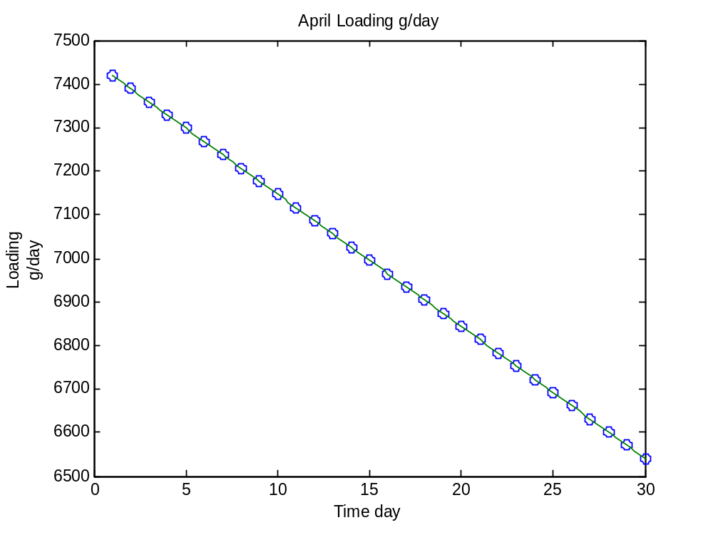
For May:
>> t5=linspace(1,31,31);
>> W5=[6510, 6615.3, 6720.783333, 6826.266667, 6931.75, 7037.233333, 7142.716667, 7248.2, 7353.683333, 7459.166667, 7564.65, 7670.133333, 7775.616667, 7881.1, 7986.583333, 8092.066667, 8197.55, 8303.033333, 8408.516667, 8514, 8619.483333, 8724.966667, 8830.45, 8935.933333, 9041.416667, 9146.9, 9252.383333, 9357.866667, 9463.35, 9568.833333, 9674.316667];
>> tt5=linspace(1,31,151);
>> vll5=interp1(t5,W5,tt5)
vll5 =
1.0e+003 *
Columns 1 through 7
6.5100 6.5311 6.5521 6.5732 6.5942 6.6153 6.6364
Columns 8 through 14
6.6575 6.6786 6.6997 6.7208 6.7419 6.7630 6.7841
Columns 15 through 21
6.8052 6.8263 6.8474 6.8685 6.8896 6.9107 6.9318
Columns 22 through 28
6.9528 6.9739 6.9950 7.0161 7.0372 7.0583 7.0794
Columns 29 through 35
7.1005 7.1216 7.1427 7.1638 7.1849 7.2060 7.2271
Columns 36 through 42
7.2482 7.2693 7.2904 7.3115 7.3326 7.3537 7.3748
Columns 43 through 49
7.3959 7.4170 7.4381 7.4592 7.4803 7.5014 7.5225
Columns 50 through 56
7.5436 7.5646 7.5857 7.6068 7.6279 7.6490 7.6701
Columns 57 through 63
7.6912 7.7123 7.7334 7.7545 7.7756 7.7967 7.8178
Columns 64 through 70
7.8389 7.8600 7.8811 7.9022 7.9233 7.9444 7.9655
Columns 71 through 77
7.9866 8.0077 8.0288 8.0499 8.0710 8.0921 8.1132
Columns 78 through 84
8.1343 8.1554 8.1765 8.1975 8.2186 8.2397 8.2608
Columns 85 through 91
8.2819 8.3030 8.3241 8.3452 8.3663 8.3874 8.4085
Columns 92 through 98
8.4296 8.4507 8.4718 8.4929 8.5140 8.5351 8.5562
Columns 99 through 105
8.5773 8.5984 8.6195 8.6406 8.6617 8.6828 8.7039
Columns 106 through 112
8.7250 8.7461 8.7672 8.7883 8.8094 8.8305 8.8515
Columns 113 through 119
8.8726 8.8937 8.9148 8.9359 8.9570 8.9781 8.9992
Columns 120 through 126
9.0203 9.0414 9.0625 9.0836 9.1047 9.1258 9.1469
Columns 127 through 133
9.1680 9.1891 9.2102 9.2313 9.2524 9.2735 9.2946
Columns 134 through 140
9.3157 9.3368 9.3579 9.3790 9.4001 9.4212 9.4423
Columns 141 through 147
9.4634 9.4844 9.5055 9.5266 9.5477 9.5688 9.5899
Columns 148 through 151
9.6110 9.6321 9.6532 9.6743
>> plot(t5,W5,'o',tt5,vll5)
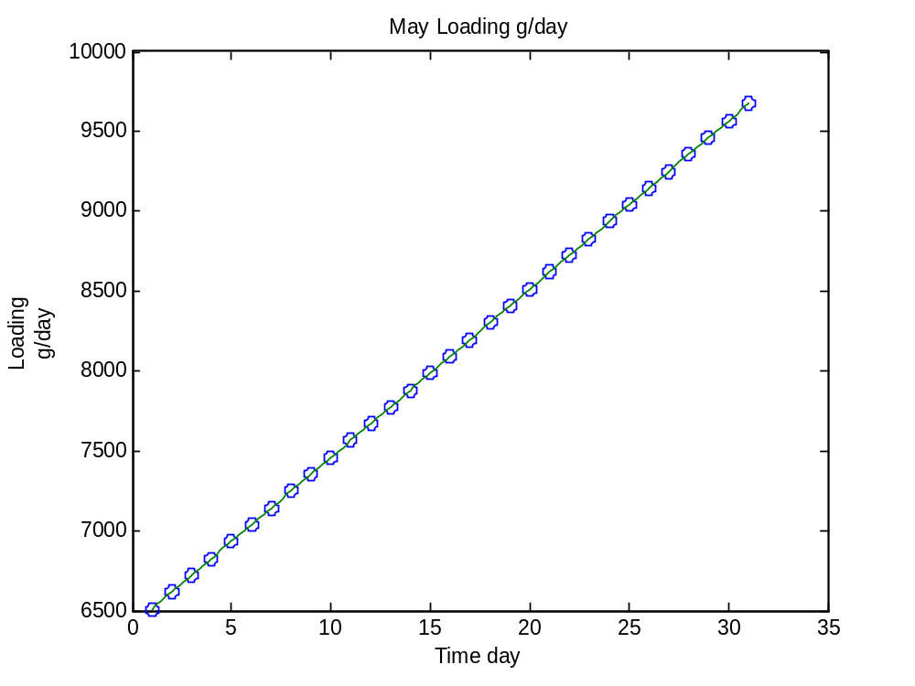
For June:
>> t6=linspace(1,30,30);
>> W6=[9780, 9633.496667, 9487.273333, 9341.05, 9194.826667, 9048.603333, 8902.38, 8756.156667, 8609.933333, 8463.71, 8317.486667, 8171.263333, 8025.04, 7878.816667, 7732.593333, 7586.37, 7440.146667, 7293.923333, 7147.7, 7001.476667, 6855.253333, 6709.03, 6562.806667, 6416.583333, 6270.36, 6124.136667, 5977.913333, 5831.69, 5685.466667, 5539.243333];
>> tt6=linspace(1,30,146);
>> vll6=interp1(t6,W6,tt6)
vll6 =
1.0e+003 *
Columns 1 through 7
9.7800 9.7507 9.7214 9.6921 9.6628 9.6335 9.6043
Columns 8 through 14
9.5750 9.5458 9.5165 9.4873 9.4580 9.4288 9.3995
Columns 15 through 21
9.3703 9.3410 9.3118 9.2826 9.2533 9.2241 9.1948
Columns 22 through 28
9.1656 9.1363 9.1071 9.0778 9.0486 9.0194 8.9901
Columns 29 through 35
8.9609 8.9316 8.9024 8.8731 8.8439 8.8146 8.7854
Columns 36 through 42
8.7562 8.7269 8.6977 8.6684 8.6392 8.6099 8.5807
Columns 43 through 49
8.5514 8.5222 8.4930 8.4637 8.4345 8.4052 8.3760
Columns 50 through 56
8.3467 8.3175 8.2882 8.2590 8.2298 8.2005 8.1713
Columns 57 through 63
8.1420 8.1128 8.0835 8.0543 8.0250 7.9958 7.9666
Columns 64 through 70
7.9373 7.9081 7.8788 7.8496 7.8203 7.7911 7.7618
Columns 71 through 77
7.7326 7.7033 7.6741 7.6449 7.6156 7.5864 7.5571
Columns 78 through 84
7.5279 7.4986 7.4694 7.4401 7.4109 7.3817 7.3524
Columns 85 through 91
7.3232 7.2939 7.2647 7.2354 7.2062 7.1769 7.1477
Columns 92 through 98
7.1185 7.0892 7.0600 7.0307 7.0015 6.9722 6.9430
Columns 99 through 105
6.9137 6.8845 6.8553 6.8260 6.7968 6.7675 6.7383
Columns 106 through 112
6.7090 6.6798 6.6505 6.6213 6.5921 6.5628 6.5336
Columns 113 through 119
6.5043 6.4751 6.4458 6.4166 6.3873 6.3581 6.3288
Columns 120 through 126
6.2996 6.2704 6.2411 6.2119 6.1826 6.1534 6.1241
Columns 127 through 133
6.0949 6.0656 6.0364 6.0072 5.9779 5.9487 5.9194
Columns 134 through 140
5.8902 5.8609 5.8317 5.8024 5.7732 5.7440 5.7147
Columns 141 through 146
5.6855 5.6562 5.6270 5.5977 5.5685 5.5392
>> plot(t6,W6,'o',tt6,vll6)
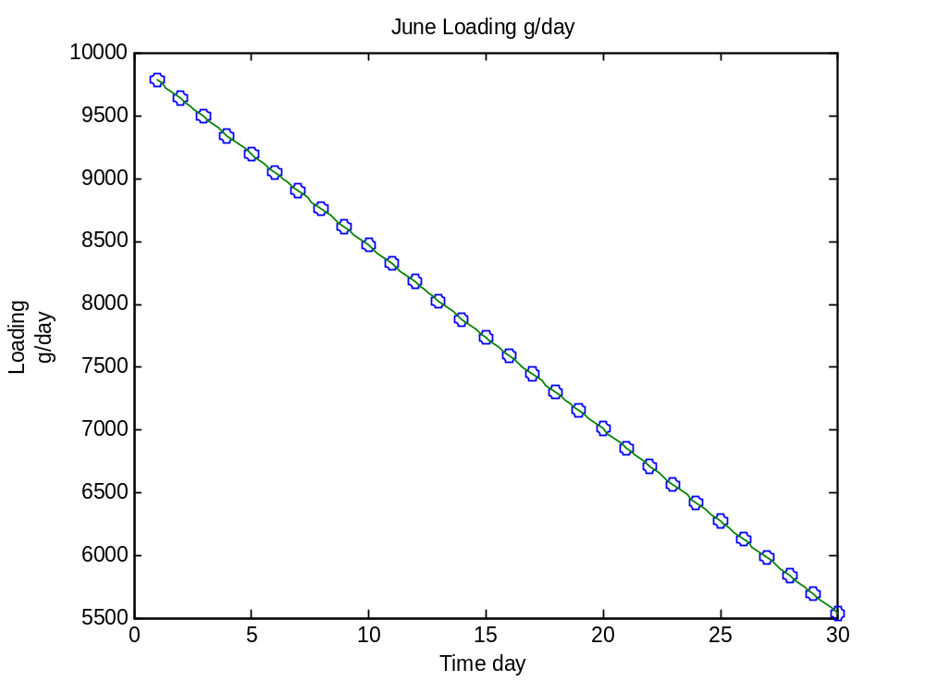
For July:
>> t7=linspace(1,31,31);
>> W7=[5393.333333, 5400.146667, 5406.706667, 5413.266667, 5419.826667, 5426.386667, 5432.946667, 5439.506667, 5446.066667, 5452.626667, 5459.186667, 5465.746667, 5472.306667, 5478.866667, 5485.426667, 5491.986667, 5498.546667, 5505.106667, 5511.666667, 5518.226667, 5524.786667, 5531.346667, 5537.906667, 5544.466667, 5551.026667, 5557.586667, 5564.146667, 5570.706667, 5577.266667, 5583.826667, 5590.386667];
>> tt7=linspace(1,31,151);
>> vll7=interp1(t7,W7,tt7)
vll7 =
1.0e+003 *
Columns 1 through 7
5.3933 5.3947 5.3961 5.3974 5.3988 5.4001 5.4015
Columns 8 through 14
5.4028 5.4041 5.4054 5.4067 5.4080 5.4093 5.4106
Columns 15 through 21
5.4120 5.4133 5.4146 5.4159 5.4172 5.4185 5.4198
Columns 22 through 28
5.4211 5.4225 5.4238 5.4251 5.4264 5.4277 5.4290
Columns 29 through 35
5.4303 5.4316 5.4329 5.4343 5.4356 5.4369 5.4382
Columns 36 through 42
5.4395 5.4408 5.4421 5.4434 5.4448 5.4461 5.4474
Columns 43 through 49
5.4487 5.4500 5.4513 5.4526 5.4539 5.4553 5.4566
Columns 50 through 56
5.4579 5.4592 5.4605 5.4618 5.4631 5.4644 5.4657
Columns 57 through 63
5.4671 5.4684 5.4697 5.4710 5.4723 5.4736 5.4749
Columns 64 through 70
5.4762 5.4776 5.4789 5.4802 5.4815 5.4828 5.4841
Columns 71 through 77
5.4854 5.4867 5.4881 5.4894 5.4907 5.4920 5.4933
Columns 78 through 84
5.4946 5.4959 5.4972 5.4985 5.4999 5.5012 5.5025
Columns 85 through 91
5.5038 5.5051 5.5064 5.5077 5.5090 5.5104 5.5117
Columns 92 through 98
5.5130 5.5143 5.5156 5.5169 5.5182 5.5195 5.5209
Columns 99 through 105
5.5222 5.5235 5.5248 5.5261 5.5274 5.5287 5.5300
Columns 106 through 112
5.5313 5.5327 5.5340 5.5353 5.5366 5.5379 5.5392
Columns 113 through 119
5.5405 5.5418 5.5432 5.5445 5.5458 5.5471 5.5484
Columns 120 through 126
5.5497 5.5510 5.5523 5.5537 5.5550 5.5563 5.5576
Columns 127 through 133
5.5589 5.5602 5.5615 5.5628 5.5641 5.5655 5.5668
Columns 134 through 140
5.5681 5.5694 5.5707 5.5720 5.5733 5.5746 5.5760
Columns 141 through 147
5.5773 5.5786 5.5799 5.5812 5.5825 5.5838 5.5851
Columns 148 through 151
5.5865 5.5878 5.5891 5.5904
>> plot(t7,W7,'o',tt7,vll7)
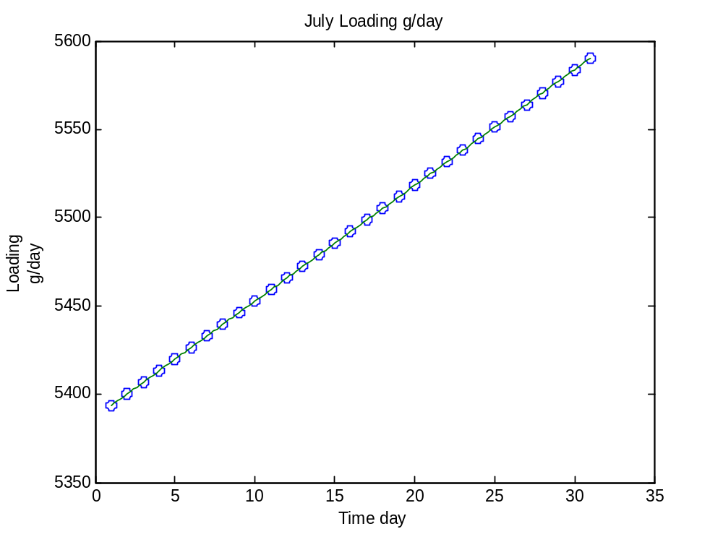
For August:
>> t8=linspace(1,31,31);
>> W8=[5596.666667, 5544.793333, 5492.683333, 5440.573333, 5388.463333, 5336.353333, 5284.243333, 5232.133333, 5180.023333, 5127.913333, 5075.803333, 5023.693333, 4971.583333, 4919.473333, 4867.363333, 4815.253333, 4763.143333, 4711.033333, 4658.923333, 4606.813333, 4554.703333, 4502.593333, 4450.483333
4398.373333, 4346.263333, 4294.153333, 4242.043333, 4189.933333, 4137.823333, 4085.713333, 4033.333333];
>> tt8=linspace(1,31,151);
>> vll8=interp1(t8,W8,tt8)
vll8 =
1.0e+003 *
Columns 1 through 7
5.5967 5.5863 5.5759 5.5655 5.5552 5.5448 5.5344
Columns 8 through 14
5.5239 5.5135 5.5031 5.4927 5.4823 5.4718 5.4614
Columns 15 through 21
5.4510 5.4406 5.4302 5.4197 5.4093 5.3989 5.3885
Columns 22 through 28
5.3780 5.3676 5.3572 5.3468 5.3364 5.3259 5.3155
Columns 29 through 35
5.3051 5.2947 5.2842 5.2738 5.2634 5.2530 5.2426
Columns 36 through 42
5.2321 5.2217 5.2113 5.2009 5.1904 5.1800 5.1696
Columns 43 through 49
5.1592 5.1488 5.1383 5.1279 5.1175 5.1071 5.0966
Columns 50 through 56
5.0862 5.0758 5.0654 5.0550 5.0445 5.0341 5.0237
Columns 57 through 63
5.0133 5.0028 4.9924 4.9820 4.9716 4.9612 4.9507
Columns 64 through 70
4.9403 4.9299 4.9195 4.9091 4.8986 4.8882 4.8778
Columns 71 through 77
4.8674 4.8569 4.8465 4.8361 4.8257 4.8153 4.8048
Columns 78 through 84
4.7944 4.7840 4.7736 4.7631 4.7527 4.7423 4.7319
Columns 85 through 91
4.7215 4.7110 4.7006 4.6902 4.6798 4.6693 4.6589
Columns 92 through 98
4.6485 4.6381 4.6277 4.6172 4.6068 4.5964 4.5860
Columns 99 through 105
4.5755 4.5651 4.5547 4.5443 4.5339 4.5234 4.5130
Columns 106 through 112
4.5026 4.4922 4.4817 4.4713 4.4609 4.4505 4.4401
Columns 113 through 119
4.4296 4.4192 4.4088 4.3984 4.3880 4.3775 4.3671
Columns 120 through 126
4.3567 4.3463 4.3358 4.3254 4.3150 4.3046 4.2942
Columns 127 through 133
4.2837 4.2733 4.2629 4.2525 4.2420 4.2316 4.2212
Columns 134 through 140
4.2108 4.2004 4.1899 4.1795 4.1691 4.1587 4.1482
Columns 141 through 147
4.1378 4.1274 4.1170 4.1066 4.0961 4.0857 4.0752
Columns 148 through 151
4.0648 4.0543 4.0438 4.0333
>> plot(t8,W8,'o',tt8,vll8)

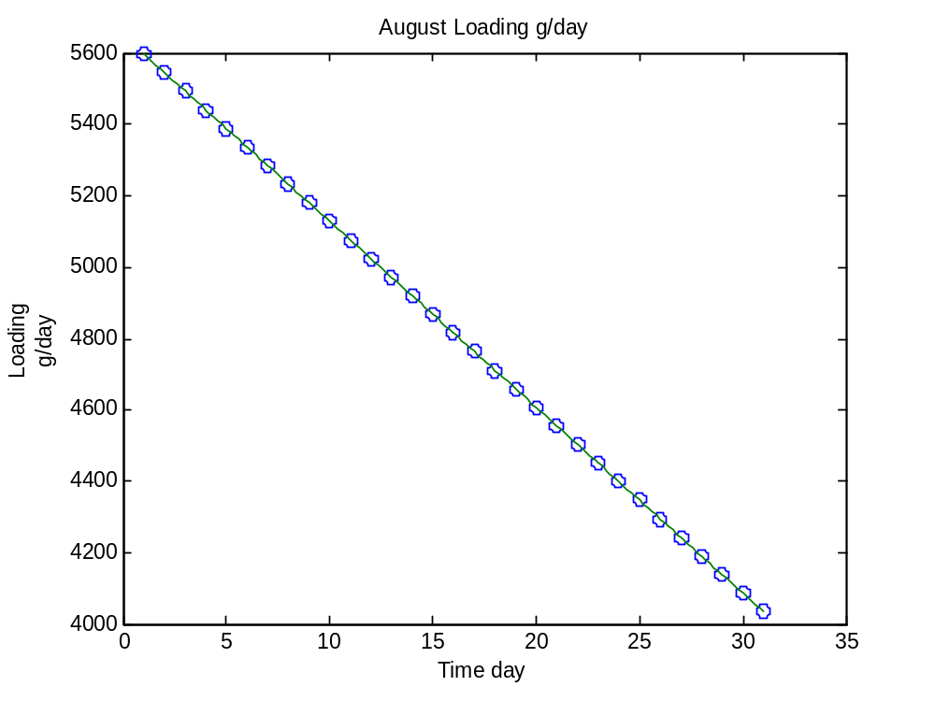
For September:
>> t9=linspace(1,30,30);
>> W9=[4016.64, 3999.866667, 3983.093333, 3966.32, 3949.546667, 3932.773333,
3916, 3899.226667, 3882.453333, 3865.68, 3848.906667, 3832.133333, 3815.36, 3798.586667, 3781.813333, 3765.04, 3748.266667, 3731.493333, 3714.72, 3697.946667, 3681.173333, 3664.4, 3647.626667, 3630.853333, 3614.08, 3597.306667, 3580.533333, 3563.76, 3546.986667, 3530.213333];
>> tt9=linspace(1,30,146);
>> vll9=interp1(t9,W9,tt9)
vll9 =
1.0e+003 *
Columns 1 through 7
4.0166 4.0133 4.0099 4.0066 4.0032 3.9999 3.9965
Columns 8 through 14
3.9932 3.9898 3.9864 3.9831 3.9797 3.9764 3.9730
Columns 15 through 21
3.9697 3.9663 3.9630 3.9596 3.9563 3.9529 3.9495
Columns 22 through 28
3.9462 3.9428 3.9395 3.9361 3.9328 3.9294 3.9261
Columns 29 through 35
3.9227 3.9194 3.9160 3.9126 3.9093 3.9059 3.9026
Columns 36 through 42
3.8992 3.8959 3.8925 3.8892 3.8858 3.8825 3.8791
Columns 43 through 49
3.8757 3.8724 3.8690 3.8657 3.8623 3.8590 3.8556
Columns 50 through 56
3.8523 3.8489 3.8456 3.8422 3.8388 3.8355 3.8321
Columns 57 through 63
3.8288 3.8254 3.8221 3.8187 3.8154 3.8120 3.8087
Columns 64 through 70
3.8053 3.8019 3.7986 3.7952 3.7919 3.7885 3.7852
Columns 71 through 77
3.7818 3.7785 3.7751 3.7717 3.7684 3.7650 3.7617
Columns 78 through 84
3.7583 3.7550 3.7516 3.7483 3.7449 3.7416 3.7382
Columns 85 through 91
3.7348 3.7315 3.7281 3.7248 3.7214 3.7181 3.7147
Columns 92 through 98
3.7114 3.7080 3.7047 3.7013 3.6979 3.6946 3.6912
Columns 99 through 105
3.6879 3.6845 3.6812 3.6778 3.6745 3.6711 3.6678
Columns 106 through 112
3.6644 3.6610 3.6577 3.6543 3.6510 3.6476 3.6443
Columns 113 through 119
3.6409 3.6376 3.6342 3.6309 3.6275 3.6241 3.6208
Columns 120 through 126
3.6174 3.6141 3.6107 3.6074 3.6040 3.6007 3.5973
Columns 127 through 133
3.5940 3.5906 3.5872 3.5839 3.5805 3.5772 3.5738
Columns 134 through 140
3.5705 3.5671 3.5638 3.5604 3.5571 3.5537 3.5503
Columns 141 through 146
3.5470 3.5436 3.5403 3.5369 3.5336 3.5302
>> plot(t9,W9,'o',tt9,vll9)
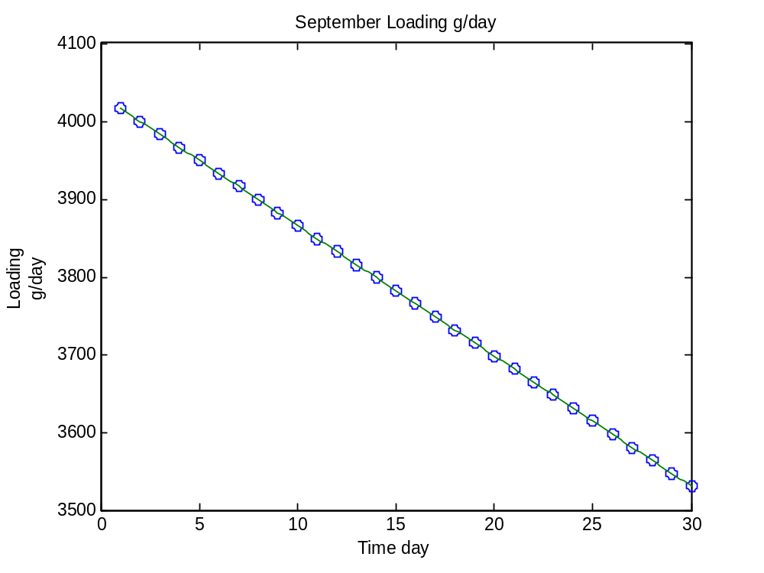
For October:
>> t10=linspace(1,31,31);
>> W10=[3513.333333, 3498, 3482.666667, 3467.333333, 3452, 3436.666667, 3421.333333, 3406, 3390.666667, 3375.333333, 3360, 3344.666667, 3329.333333, 3314, 3298.666667, 3283.333333, 3268, 3252.666667, 3237.333333, 3222, 3206.666667, 3191.333333, 3176, 3160.666667, 3145.333333, 3130, 3114.666667, 3099.333333, 3084, 3068.666667, 3053.333333];
>> tt10=linspace(1,31,151);
>> vll10=interp1(t10,W10,tt10)
vll10 =
1.0e+003 *
Columns 1 through 7
3.5133 3.5103 3.5072 3.5041 3.5011 3.4980 3.4949
Columns 8 through 14
3.4919 3.4888 3.4857 3.4827 3.4796 3.4765 3.4735
Columns 15 through 21
3.4704 3.4673 3.4643 3.4612 3.4581 3.4551 3.4520
Columns 22 through 28
3.4489 3.4459 3.4428 3.4397 3.4367 3.4336 3.4305
Columns 29 through 35
3.4275 3.4244 3.4213 3.4183 3.4152 3.4121 3.4091
Columns 36 through 42
3.4060 3.4029 3.3999 3.3968 3.3937 3.3907 3.3876
Columns 43 through 49
3.3845 3.3815 3.3784 3.3753 3.3723 3.3692 3.3661
Columns 50 through 56
3.3631 3.3600 3.3569 3.3539 3.3508 3.3477 3.3447
Columns 57 through 63
3.3416 3.3385 3.3355 3.3324 3.3293 3.3263 3.3232
Columns 64 through 70
3.3201 3.3171 3.3140 3.3109 3.3079 3.3048 3.3017
Columns 71 through 77
3.2987 3.2956 3.2925 3.2895 3.2864 3.2833 3.2803
Columns 78 through 84
3.2772 3.2741 3.2711 3.2680 3.2649 3.2619 3.2588
Columns 85 through 91
3.2557 3.2527 3.2496 3.2465 3.2435 3.2404 3.2373
Columns 92 through 98
3.2343 3.2312 3.2281 3.2251 3.2220 3.2189 3.2159
Columns 99 through 105
3.2128 3.2097 3.2067 3.2036 3.2005 3.1975 3.1944
Columns 106 through 112
3.1913 3.1883 3.1852 3.1821 3.1791 3.1760 3.1729
Columns 113 through 119
3.1699 3.1668 3.1637 3.1607 3.1576 3.1545 3.1515
Columns 120 through 126
3.1484 3.1453 3.1423 3.1392 3.1361 3.1331 3.1300
Columns 127 through 133
3.1269 3.1239 3.1208 3.1177 3.1147 3.1116 3.1085
Columns 134 through 140
3.1055 3.1024 3.0993 3.0963 3.0932 3.0901 3.0871
Columns 141 through 147
3.0840 3.0809 3.0779 3.0748 3.0717 3.0687 3.0656
Columns 148 through 151
3.0625 3.0595 3.0564 3.0533
>> plot(t10,W10,'o',tt10,vll10)
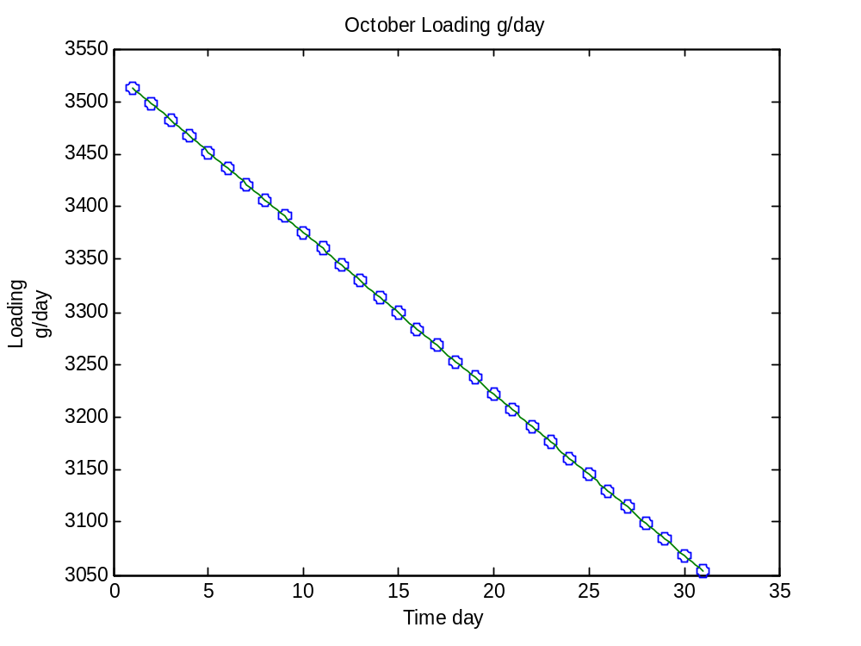
For November:
>> t11=linspace(1,30,30);
>> W11=[3084, 3114.666667, 3145.333333, 3176, 3206.666667, 3237.333333, 3268, 3298.666667, 3329.333333, 3360, 3390.666667, 3421.333333, 3452, 3482.666667, 3513.333333, 3544, 3574.666667, 3605.333333, 3636, 3666.666667, 3697.333333, 3728, 3758.666667, 3789.333333, 3820, 3850.666667, 3881.333333, 3912, 3942.666667, 3973.333333];
>> tt11=linspace(1,30,146);
>> vll11=interp1(t11,W11,tt11)
vll11 =
1.0e+003 *
Columns 1 through 7
3.0840 3.0901 3.0963 3.1024 3.1085 3.1147 3.1208
Columns 8 through 14
3.1269 3.1331 3.1392 3.1453 3.1515 3.1576 3.1637
Columns 15 through 21
3.1699 3.1760 3.1821 3.1883 3.1944 3.2005 3.2067
Columns 22 through 28
3.2128 3.2189 3.2251 3.2312 3.2373 3.2435 3.2496
Columns 29 through 35
3.2557 3.2619 3.2680 3.2741 3.2803 3.2864 3.2925
Columns 36 through 42
3.2987 3.3048 3.3109 3.3171 3.3232 3.3293 3.3355
Columns 43 through 49
3.3416 3.3477 3.3539 3.3600 3.3661 3.3723 3.3784
Columns 50 through 56
3.3845 3.3907 3.3968 3.4029 3.4091 3.4152 3.4213
Columns 57 through 63
3.4275 3.4336 3.4397 3.4459 3.4520 3.4581 3.4643
Columns 64 through 70
3.4704 3.4765 3.4827 3.4888 3.4949 3.5011 3.5072
Columns 71 through 77
3.5133 3.5195 3.5256 3.5317 3.5379 3.5440 3.5501
Columns 78 through 84
3.5563 3.5624 3.5685 3.5747 3.5808 3.5869 3.5931
Columns 85 through 91
3.5992 3.6053 3.6115 3.6176 3.6237 3.6299 3.6360
Columns 92 through 98
3.6421 3.6483 3.6544 3.6605 3.6667 3.6728 3.6789
Columns 99 through 105
3.6851 3.6912 3.6973 3.7035 3.7096 3.7157 3.7219
Columns 106 through 112
3.7280 3.7341 3.7403 3.7464 3.7525 3.7587 3.7648
Columns 113 through 119
3.7709 3.7771 3.7832 3.7893 3.7955 3.8016 3.8077
Columns 120 through 126
3.8139 3.8200 3.8261 3.8323 3.8384 3.8445 3.8507
Columns 127 through 133
3.8568 3.8629 3.8691 3.8752 3.8813 3.8875 3.8936
Columns 134 through 140
3.8997 3.9059 3.9120 3.9181 3.9243 3.9304 3.9365
Columns 141 through 146
3.9427 3.9488 3.9549 3.9611 3.9672 3.9733
>> plot(t11,W11,'o',tt11,vll11)
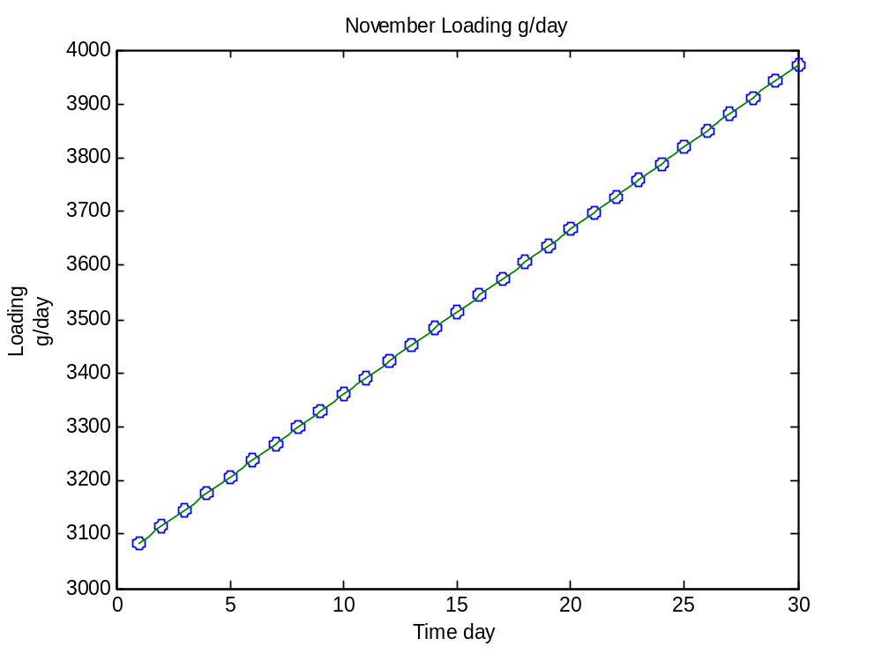
For December:
>> t12=linspace(1,31,31);
>> W12=[3973.333333, 3973.333333, 3973.333333, 3973.333333, 3973.333333, 3973.333333, 3973.333333, 3973.333333, 3973.333333, 3973.333333, 3973.333333, 3973.333333, 3973.333333, 3973.333333, 3973.333333, 3973.333333, 3973.333333, 3973.333333, 3973.333333, 3973.333333, 3973.333333, 3973.333333, 3973.333333, 3973.333333, 3973.333333, 3973.333333, 3973.333333, 3973.333333, 3973.333333, 3973.333333, 3973.333333];
>> tt12=linspace(1,31,151);
>> vll12=interp1(t12,W12,tt12)
vll12 =
1.0e+003 *
Columns 1 through 7
3.9733 3.9733 3.9733 3.9733 3.9733 3.9733 3.9733
Columns 8 through 14
3.9733 3.9733 3.9733 3.9733 3.9733 3.9733 3.9733
Columns 15 through 21
3.9733 3.9733 3.9733 3.9733 3.9733 3.9733 3.9733
Columns 22 through 28
3.9733 3.9733 3.9733 3.9733 3.9733 3.9733 3.9733
Columns 29 through 35
3.9733 3.9733 3.9733 3.9733 3.9733 3.9733 3.9733
Columns 36 through 42
3.9733 3.9733 3.9733 3.9733 3.9733 3.9733 3.9733
Columns 43 through 49
3.9733 3.9733 3.9733 3.9733 3.9733 3.9733 3.9733
Columns 50 through 56
3.9733 3.9733 3.9733 3.9733 3.9733 3.9733 3.9733
Columns 57 through 63
3.9733 3.9733 3.9733 3.9733 3.9733 3.9733 3.9733
Columns 64 through 70
3.9733 3.9733 3.9733 3.9733 3.9733 3.9733 3.9733
Columns 71 through 77
3.9733 3.9733 3.9733 3.9733 3.9733 3.9733 3.9733
Columns 78 through 84
3.9733 3.9733 3.9733 3.9733 3.9733 3.9733 3.9733
Columns 85 through 91
3.9733 3.9733 3.9733 3.9733 3.9733 3.9733 3.9733
Columns 92 through 98
3.9733 3.9733 3.9733 3.9733 3.9733 3.9733 3.9733
Columns 99 through 105
3.9733 3.9733 3.9733 3.9733 3.9733 3.9733 3.9733
Columns 106 through 112
3.9733 3.9733 3.9733 3.9733 3.9733 3.9733 3.9733
Columns 113 through 119
3.9733 3.9733 3.9733 3.9733 3.9733 3.9733 3.9733
Columns 120 through 126
3.9733 3.9733 3.9733 3.9733 3.9733 3.9733 3.9733
Columns 127 through 133
3.9733 3.9733 3.9733 3.9733 3.9733 3.9733 3.9733
Columns 134 through 140
3.9733 3.9733 3.9733 3.9733 3.9733 3.9733 3.9733
Columns 141 through 147
3.9733 3.9733 3.9733 3.9733 3.9733 3.9733 3.9733
Columns 148 through 151
3.9733 3.9733 3.9733 3.9733
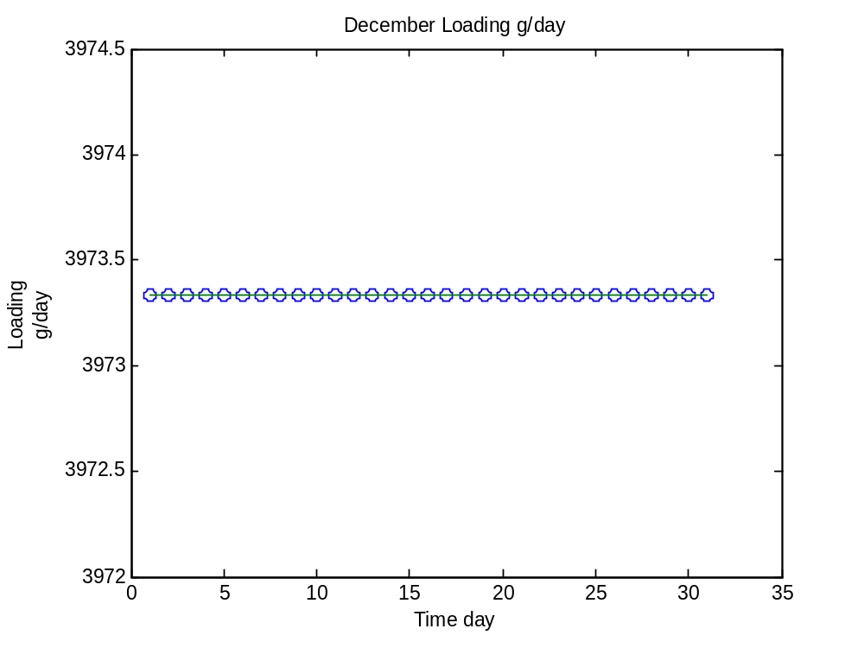
(b). Linear Interpolation applying step size t=0.5day
Using Matlab to solve:
For January:
>> t=linspace(1,31,31);
>> W=[4353.333333, 4361.46, 4369.523333, 4377.586667, 4385.65, 4393.713333, 4401.776667, 4409.84, 4417.903333, 4425.966667, 4434.03, 4442.093333, 4450.156667, 4458.22, 4466.283333, 4474.346667, 4482.41, 4490.473333, 4498.536667, 4506.6, 4514.663333, 4522.726667, 4530.79, 4538.853333, 4546.916667, 4554.98, 4563.043333, 4571.106667, 4579.17, 4587.233333, 4595.296667];
>> tt=linspace(1,31,61);
>> vll=interp1(t,W,tt)
vll =
1.0e+003 *
Columns 1 through 11
4.3533 4.3574 4.3615 4.3655 4.3695 4.3736 4.3776 4.3816 4.3857 4.3897 4.3937
Columns 12 through 22
4.3977 4.4018 4.4058 4.4098 4.4139 4.4179 4.4219 4.4260 4.4300 4.4340 4.4381
Columns 23 through 33
4.4421 4.4461 4.4502 4.4542 4.4582 4.4623 4.4663 4.4703 4.4743 4.4784 4.4824
Columns 34 through 44
4.4864 4.4905 4.4945 4.4985 4.5026 4.5066 4.5106 4.5147 4.5187 4.5227 4.5268
Columns 45 through 55
4.5308 4.5348 4.5389 4.5429 4.5469 4.5509 4.5550 4.5590 4.5630 4.5671 4.5711
Columns 56 through 61
4.5751 4.5792 4.5832 4.5872 4.5913 4.5953
>> plot(t,W,'o',tt,vll)
For February:
>> t2=linspace(1,28,28);
>> W2=[4603.333333, 4645.16, 4686.946667, 4728.733333, 4770.52, 4812.306667, 4854.093333, 4895.88, 4937.666667, 4979.453333, 5021.24, 5063.026667, 5104.813333, 5146.6, 5188.386667, 5230.173333, 5271.96, 5313.746667, 5355.533333, 5397.32, 5439.106667, 5480.893333, 5522.68, 5564.466667, 5606.253333, 5648.04, 5689.826667, 5731.613333];
>> tt2=linspace(1,28,136)
>> vll2=interp1(t2,W2,tt2)
vll2 =
1.0e+003 *
Columns 1 through 11
4.6033 4.6242 4.6452 4.6661 4.6869 4.7078 4.7287 4.7496 4.7705 4.7914 4.8123
Columns 12 through 22
4.8332 4.8541 4.8750 4.8959 4.9168 4.9377 4.9586 4.9795 5.0003 5.0212 5.0421
Columns 23 through 33
5.0630 5.0839 5.1048 5.1257 5.1466 5.1675 5.1884 5.2093 5.2302 5.2511 5.2720
Columns 34 through 44
5.2929 5.3137 5.3346 5.3555 5.3764 5.3973 5.4182 5.4391 5.4600 5.4809 5.5018
Columns 45 through 55
5.5227 5.5436 5.5645 5.5854 5.6063 5.6271 5.6480 5.6689 5.6898 5.7107 5.7316
>> plot(t2,W2,'o',tt2,vll2)
For March:
>> t3=linspace(1,31,31);
>> W3=[5773.333333, 5829.29, 5885.18, 5941.07, 5996.96, 6052.85, 6108.74, 6164.63, 6220.52, 6276.41, 6332.3, 6388.19, 6444.08, 6499.97, 6555.86, 6611.75, 6667.64, 6723.53, 6779.42, 6835.31, 6891.2, 6947.09, 7002.98, 7058.87, 7114.76, 7170.65, 7226.54, 7282.43, 7338.32, 7394.21, 7450];
>> tt3=linspace(1,31,151);
>> vll3=interp1(t3,W3,tt3)
vll3 =
1.0e+003 *
Columns 1 through 11
5.7733 5.8013 5.8293 5.8572 5.8852 5.9131 5.9411 5.9690 5.9970 6.0249 6.0529
Columns 12 through 22
6.0808 6.1087 6.1367 6.1646 6.1926 6.2205 6.2485 6.2764 6.3044 6.3323 6.3602
Columns 23 through 33
6.3882 6.4161 6.4441 6.4720 6.5000 6.5279 6.5559 6.5838 6.6117 6.6397 6.6676
Columns 34 through 44
6.6956 6.7235 6.7515 6.7794 6.8074 6.8353 6.8633 6.8912 6.9191 6.9471 6.9750
Columns 45 through 55
7.0030 7.0309 7.0589 7.0868 7.1148 7.1427 7.1706 7.1986 7.2265 7.2545 7.2824
Columns 56 through 61
7.3104 7.3383 7.3663 7.3942 7.4221 7.4500
>> plot(t3,W3,'o',tt3,vll3)
For April:
>> t4=linspace(1,30,30);
>> W4=[7419.576667, 7389.253333, 7358.93, 7328.606667, 7298.283333, 7267.96, 7237.636667, 7207.313333, 7176.99, 7146.666667, 7116.343333, 7086.02, 7055.696667, 7025.373333, 6995.05, 6964.726667, 6934.403333, 6904.08, 6873.756667, 6843.433333, 6813.11, 6782.786667, 6752.463333, 6722.14, 6691.816667, 6661.493333, 6631.17, 6600.846667, 6570.523333, 6540.2];
>> tt4=linspace(1,30,146);
>> vll4=interp1(t4,W4,tt4)
vll4 =
1.0e+003 *
Columns 1 through 11
7.4196 7.4044 7.3893 7.3741 7.3589 7.3438 7.3286 7.3134 7.2983 7.2831 7.2680
Columns 12 through 22
7.2528 7.2376 7.2225 7.2073 7.1922 7.1770 7.1618 7.1467 7.1315 7.1163 7.1012
Columns 23 through 33
7.0860 7.0709 7.0557 7.0405 7.0254 7.0102 6.9951 6.9799 6.9647 6.9496 6.9344
Columns 34 through 44
6.9192 6.9041 6.8889 6.8738 6.8586 6.8434 6.8283 6.8131 6.7979 6.7828 6.7676
Columns 45 through 55
6.7525 6.7373 6.7221 6.7070 6.6918 6.6767 6.6615 6.6463 6.6312 6.6160 6.6008
Columns 56 through 59
6.5857 6.5705 6.5554 6.5402
>> plot(t4,W4,'o',tt4,vll4)
For May:
>> t5=linspace(1,31,31);
>> W5=[6510, 6615.3, 6720.783333, 6826.266667, 6931.75, 7037.233333, 7142.716667, 7248.2, 7353.683333, 7459.166667, 7564.65, 7670.133333, 7775.616667, 7881.1, 7986.583333, 8092.066667, 8197.55, 8303.033333, 8408.516667, 8514, 8619.483333, 8724.966667, 8830.45, 8935.933333, 9041.416667, 9146.9, 9252.383333, 9357.866667, 9463.35, 9568.833333, 9674.316667];
>> tt5=linspace(1,31,151);
>> vll5=interp1(t5,W5,tt5)
vll5 =
1.0e+003 *
Columns 1 through 11
6.5100 6.5626 6.6153 6.6680 6.7208 6.7735 6.8263 6.8790 6.9318 6.9845 7.0372
Columns 12 through 22
7.0900 7.1427 7.1955 7.2482 7.3009 7.3537 7.4064 7.4592 7.5119 7.5646 7.6174
Columns 23 through 33
7.6701 7.7229 7.7756 7.8284 7.8811 7.9338 7.9866 8.0393 8.0921 8.1448 8.1975
Columns 34 through 44
8.2503 8.3030 8.3558 8.4085 8.4613 8.5140 8.5667 8.6195 8.6722 8.7250 8.7777
Columns 45 through 55
8.8305 8.8832 8.9359 8.9887 9.0414 9.0942 9.1469 9.1996 9.2524 9.3051 9.3579
Columns 56 through 61
9.4106 9.4634 9.5161 9.5688 9.6216 9.6743
>> plot(t5,W5,'o',tt5,vll5)
For June:
>> t6=linspace(1,30,30);
>> W6=[9780, 9633.496667, 9487.273333, 9341.05, 9194.826667, 9048.603333, 8902.38, 8756.156667, 8609.933333, 8463.71, 8317.486667, 8171.263333, 8025.04, 7878.816667, 7732.593333, 7586.37, 7440.146667, 7293.923333, 7147.7, 7001.476667, 6855.253333, 6709.03, 6562.806667, 6416.583333, 6270.36, 6124.136667, 5977.913333, 5831.69, 5685.466667, 5539.243333];
>> tt6=linspace(1,30,146);
>> vll6=interp1(t6,W6,tt6)
vll6 =
1.0e+003 *
Columns 1 through 11
9.7800 9.7067 9.6335 9.5604 9.4873 9.4142 9.3410 9.2679 9.1948 9.1217 9.0486
Columns 12 through 22
8.9755 8.9024 8.8293 8.7562 8.6830 8.6099 8.5368 8.4637 8.3906 8.3175 8.2444
Columns 23 through 33
8.1713 8.0982 8.0250 7.9519 7.8788 7.8057 7.7326 7.6595 7.5864 7.5133 7.4401
Columns 34 through 44
7.3670 7.2939 7.2208 7.1477 7.0746 7.0015 6.9284 6.8553 6.7821 6.7090 6.6359
Columns 45 through 55
6.5628 6.4897 6.4166 6.3435 6.2704 6.1972 6.1241 6.0510 5.9779 5.9048 5.8317
Columns 56 through 59
5.7586 5.6855 5.6124 5.5392
>> plot(t6,W6,'o',tt6,vll6)
For July:
>> t7=linspace(1,31,31);
>> W7=[5393.333333, 5400.146667, 5406.706667, 5413.266667, 5419.826667, 5426.386667, 5432.946667, 5439.506667, 5446.066667, 5452.626667, 5459.186667, 5465.746667, 5472.306667, 5478.866667, 5485.426667, 5491.986667, 5498.546667, 5505.106667, 5511.666667, 5518.226667, 5524.786667, 5531.346667, 5537.906667, 5544.466667, 5551.026667, 5557.586667, 5564.146667, 5570.706667, 5577.266667, 5583.826667, 5590.386667];
>> tt7=linspace(1,31,151);
>> vll7=interp1(t7,W7,tt7)
vll7 =
1.0e+003 *
Columns 1 through 11
5.3933 5.3967 5.4001 5.4034 5.4067 5.4100 5.4133 5.4165 5.4198 5.4231 5.4264
Columns 12 through 22
5.4297 5.4329 5.4362 5.4395 5.4428 5.4461 5.4493 5.4526 5.4559 5.4592 5.4625
Columns 23 through 33
5.4657 5.4690 5.4723 5.4756 5.4789 5.4821 5.4854 5.4887 5.4920 5.4953 5.4985
Columns 34 through 44
5.5018 5.5051 5.5084 5.5117 5.5149 5.5182 5.5215 5.5248 5.5281 5.5313 5.5346
Columns 45 through 55
5.5379 5.5412 5.5445 5.5477 5.5510 5.5543 5.5576 5.5609 5.5641 5.5674 5.5707
Columns 56 through 61
5.5740 5.5773 5.5805 5.5838 5.5871 5.5904
>> plot(t7,W7,'o',tt7,vll7)
For August:
>> t8=linspace(1,31,31);
>> W8=[5596.666667, 5544.793333, 5492.683333, 5440.573333, 5388.463333, 5336.353333, 5284.243333, 5232.133333, 5180.023333, 5127.913333, 5075.803333, 5023.693333, 4971.583333, 4919.473333, 4867.363333, 4815.253333, 4763.143333, 4711.033333, 4658.923333, 4606.813333, 4554.703333, 4502.593333, 4450.483333
4398.373333, 4346.263333, 4294.153333, 4242.043333, 4189.933333, 4137.823333, 4085.713333, 4033.333333];
>> tt8=linspace(1,31,151);
>> vll8=interp1(t8,W8,tt8)
vll8 =
1.0e+003 *
Columns 1 through 11
5.5967 5.5707 5.5448 5.5187 5.4927 5.4666 5.4406 5.4145 5.3885 5.3624 5.3364
Columns 12 through 22
5.3103 5.2842 5.2582 5.2321 5.2061 5.1800 5.1540 5.1279 5.1019 5.0758 5.0497
Columns 23 through 33
5.0237 4.9976 4.9716 4.9455 4.9195 4.8934 4.8674 4.8413 4.8153 4.7892 4.7631
Columns 34 through 44
4.7371 4.7110 4.6850 4.6589 4.6329 4.6068 4.5808 4.5547 4.5286 4.5026 4.4765
Columns 45 through 55
4.4505 4.4244 4.3984 4.3723 4.3463 4.3202 4.2942 4.2681 4.2420 4.2160 4.1899
Columns 56 through 61
4.1639 4.1378 4.1118 4.0857 4.0595 4.0333
>> plot(t8,W8,'o',tt8,vll8)

For September:
>> t9=linspace(1,30,30);
>> W9=[4016.64, 3999.866667, 3983.093333, 3966.32, 3949.546667, 3932.773333,
3916, 3899.226667, 3882.453333, 3865.68, 3848.906667, 3832.133333, 3815.36, 3798.586667, 3781.813333, 3765.04, 3748.266667, 3731.493333, 3714.72, 3697.946667, 3681.173333, 3664.4, 3647.626667, 3630.853333, 3614.08, 3597.306667, 3580.533333, 3563.76, 3546.986667, 3530.213333];
>> tt9=linspace(1,30,146);
>> vll9=interp1(t9,W9,tt9)
vll9 =
1.0e+003 *
Columns 1 through 11
4.0166 4.0083 3.9999 3.9915 3.9831 3.9747 3.9663 3.9579 3.9495 3.9412 3.9328
Columns 12 through 22
3.9244 3.9160 3.9076 3.8992 3.8908 3.8825 3.8741 3.8657 3.8573 3.8489 3.8405
Columns 23 through 33
3.8321 3.8237 3.8154 3.8070 3.7986 3.7902 3.7818 3.7734 3.7650 3.7567 3.7483
Columns 34 through 44
3.7399 3.7315 3.7231 3.7147 3.7063 3.6979 3.6896 3.6812 3.6728 3.6644 3.6560
Columns 45 through 55
3.6476 3.6392 3.6309 3.6225 3.6141 3.6057 3.5973 3.5889 3.5805 3.5721 3.5638
Columns 56 through 59
3.5554 3.5470 3.5386 3.5302
>> plot(t9,W9,'o',tt9,vll9)
For October:
>> t10=linspace(1,31,31);
>> W10=[3513.333333, 3498, 3482.666667, 3467.333333, 3452, 3436.666667, 3421.333333, 3406, 3390.666667, 3375.333333, 3360, 3344.666667, 3329.333333, 3314, 3298.666667, 3283.333333, 3268, 3252.666667, 3237.333333, 3222, 3206.666667, 3191.333333, 3176, 3160.666667, 3145.333333, 3130, 3114.666667, 3099.333333, 3084, 3068.666667, 3053.333333];
>> tt10=linspace(1,31,151);
>> vll10=interp1(t10,W10,tt10)
vll10 =
1.0e+003 *
Columns 1 through 11
3.5133 3.5057 3.4980 3.4903 3.4827 3.4750 3.4673 3.4597 3.4520 3.4443 3.4367
Columns 12 through 22
3.4290 3.4213 3.4137 3.4060 3.3983 3.3907 3.3830 3.3753 3.3677 3.3600 3.3523
Columns 23 through 33
3.3447 3.3370 3.3293 3.3217 3.3140 3.3063 3.2987 3.2910 3.2833 3.2757 3.2680
Columns 34 through 44
3.2603 3.2527 3.2450 3.2373 3.2297 3.2220 3.2143 3.2067 3.1990 3.1913 3.1837
Columns 45 through 55
3.1760 3.1683 3.1607 3.1530 3.1453 3.1377 3.1300 3.1223 3.1147 3.1070 3.0993
Columns 56 through 61
3.0917 3.0840 3.0763 3.0687 3.0610 3.0533
>> plot(t10,W10,'o',tt10,vll10)
For November:
>> t11=linspace(1,30,30);
>> W11=[3084, 3114.666667, 3145.333333, 3176, 3206.666667, 3237.333333, 3268, 3298.666667, 3329.333333, 3360, 3390.666667, 3421.333333, 3452, 3482.666667, 3513.333333, 3544, 3574.666667, 3605.333333, 3636, 3666.666667, 3697.333333, 3728, 3758.666667, 3789.333333, 3820, 3850.666667, 3881.333333, 3912, 3942.666667, 3973.333333];
>> tt11=linspace(1,30,146);
>> vll11=interp1(t11,W11,tt11)
vll11 =
1.0e+003 *
Columns 1 through 11
3.0840 3.0993 3.1147 3.1300 3.1453 3.1607 3.1760 3.1913 3.2067 3.2220 3.2373
Columns 12 through 22
3.2527 3.2680 3.2833 3.2987 3.3140 3.3293 3.3447 3.3600 3.3753 3.3907 3.4060
Columns 23 through 33
3.4213 3.4367 3.4520 3.4673 3.4827 3.4980 3.5133 3.5287 3.5440 3.5593 3.5747
Columns 34 through 44
3.5900 3.6053 3.6207 3.6360 3.6513 3.6667 3.6820 3.6973 3.7127 3.7280 3.7433
Columns 45 through 55
3.7587 3.7740 3.7893 3.8047 3.8200 3.8353 3.8507 3.8660 3.8813 3.8967 3.9120
Columns 56 through 59
3.9273 3.9427 3.9580 3.9733
>> plot(t11,W11,'o',tt11,vll11)
For December:
>> t12=linspace(1,31,31);
>> W12=[3973.333333, 3973.333333, 3973.333333, 3973.333333, 3973.333333, 3973.333333, 3973.333333, 3973.333333, 3973.333333, 3973.333333, 3973.333333, 3973.333333, 3973.333333, 3973.333333, 3973.333333, 3973.333333, 3973.333333, 3973.333333, 3973.333333, 3973.333333, 3973.333333, 3973.333333, 3973.333333, 3973.333333, 3973.333333, 3973.333333, 3973.333333, 3973.333333, 3973.333333, 3973.333333, 3973.333333];
>> tt12=linspace(1,31,151);
>> vll12=interp1(t12,W12,tt12)
vll12 =
1.0e+003 *
Columns 1 through 11
3.9733 3.9733 3.9733 3.9733 3.9733 3.9733 3.9733 3.9733 3.9733 3.9733 3.9733
Columns 12 through 22
3.9733 3.9733 3.9733 3.9733 3.9733 3.9733 3.9733 3.9733 3.9733 3.9733 3.9733
Columns 23 through 33
3.9733 3.9733 3.9733 3.9733 3.9733 3.9733 3.9733 3.9733 3.9733 3.9733 3.9733
Columns 34 through 44
3.9733 3.9733 3.9733 3.9733 3.9733 3.9733 3.9733 3.9733 3.9733 3.9733 3.9733
Columns 45 through 55
3.9733 3.9733 3.9733 3.9733 3.9733 3.9733 3.9733 3.9733 3.9733 3.9733 3.9733
Columns 56 through 61
3.9733 3.9733 3.9733 3.9733 3.9733 3.9733
>> plot(t12,Q12,'o',tt12,vl12)

